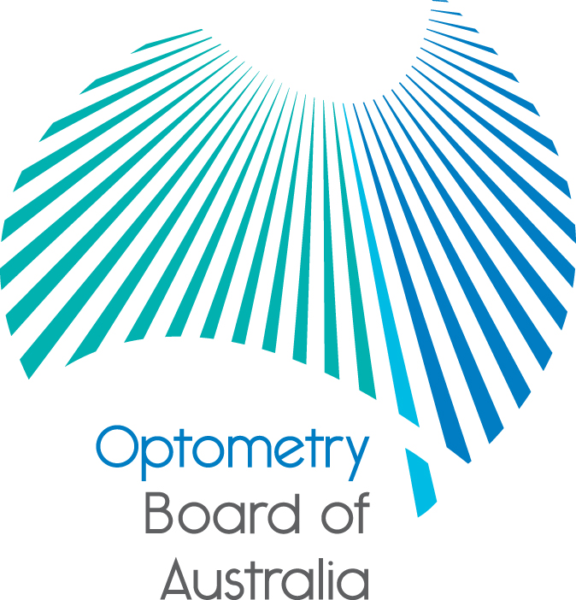
Communiqué: Optometry Board of Australia

August 2018 meeting
The 95th meeting of the Optometry Board of Australia (the Board) was held on 30 August 2018 at the Australian Health Practitioner Regulation Agency (AHPRA) National office in Melbourne.
This communiqué outlines the issues and decisions from this meeting as well as other points of interest. We publish it on our website and email it to a broad range of stakeholders. Please forward it to your colleagues and employees who may be interested.
Revised Endorsement for scheduled medicines registration standard and guidelines for use
Following a transition period from June 2018, revised Endorsements for scheduled medicines registration standard and Guidelines for use of scheduled medicines are now effective from 10 September 2018.
The registration standard sets out the requirements that an optometrist must meet to be granted an endorsement. The related guidelines outline the Board’s expectations about the use of scheduled medicines by endorsed and non-endorsed optometrists. The guidelines apply to optometrists with general registration who use scheduled medicines for diagnostic purposes and to optometrists whose registration is endorsed for scheduled medicines, who use scheduled medicines for the purposes of the practice of optometry.
Appendix B of the guidelines contains the revised Board-approved list of topical scheduled medicines that endorsed optometrists are qualified to prescribe for the purposes of the practice of optometry. The list is also published on the Board’s website. An FAQ has been developed to provide further information about the changes and the Board’s expectations.
All registered optometrists with a scheduled medicines endorsement are required to be familiar with and comply with the current legislative requirements in the jurisdictions in which they practise.
Victorian Optometrists Training and Education (VOTE) Trust
The Victorian Optometrists Training and Education (VOTE) Trust was established in 2010 by the Optometrists Registration Board of Victoria from funds accumulated and held by the Board.
Following the introduction of the National Registration and Accreditation Scheme (the National Scheme) for optometry and other health professions in Australia in July 2010, the Victorian Board ceased to exist. Ministerial approval had been secured for some of the Victorian Boards reserve funds to be transferred to a trustee. The remainder of the funds were transferred to the newly established Optometry Board of Australia.
The VOTE trust fund was initially established with $490,000 with the requirements that the funds are to be held in perpetuity, invested and the income from the fund dispersed through annual grants and awards. The Guardian of the fund is the Victorian Health Minister and a Grants Advisory Committee is appointed comprising nominees of the Department of Optometry and Vision Sciences, University of Melbourne; Optometrists Victoria; Australian College of Optometry and Optometry Board of Australia.
The principal purpose of the VOTE Trust is to:
- advance and foster the practice of optometry and related techniques, procedures and policies, principally in Victoria, through research and education, to improve patient outcomes, and
- improve Victorian optometrists’ ability to practise and Victorian students’ ability to undertake training, principally in Victoria.
Applications for projects from other states/territories of Australia and from non-optometrists interested in the profession will be considered.
The 2018–2019 applications are now open and will close at 5.00pm AEST on 5 October 2018. Applicants can apply on the Perpetual Smartygrants website (the link is live until 5.00pm on 5 October only).
Guidelines for 2018–2019 applicants are available in the following document:
VOTE Trust training and education grants 2018-2019 (101 KB,PDF), Word version (30.4 KB,DOCX)
AHPRA to conduct pilot audit on advertising compliance in early 2019
A pilot audit to check health practitioner compliance with advertising requirements will be conducted by the Australian Health Practitioner Regulation Agency (AHPRA) in early 2019.
Random audits of advertising compliance will advance a risk-based approach to enforcing the National Law’s advertising requirements and facilitate compliance by all registered health practitioners who advertise their services.
The National Boards for chiropractic and dental are taking part in the pilot audit.
The pilot audit has been modelled on the well-established approach to auditing compliance with core registration standards and involves adding an extra declaration about advertising compliance when chiropractors and dental practitioners apply for renewal of registration in 2018. (The National Law¹ enables a National Board to require any other reasonable information to be included with a renewal application.)
The pilot will not delay a decision on the application for renewal.
The audit will be carried out by AHPRA’s Advertising Compliance Team from January 2019 and will involve a random sample of chiropractors and dental practitioners who renewed their registration in 2018.
One of the audit’s main objectives is to analyse the rate of advertising compliance for those health practitioners who advertise and who have not been the subject of an advertising complaint in the past 12 months.
A pilot audit report including data analysis and recommendations will be prepared for National Boards to consider the pilot outcomes and implications for future compliance work.
For information about your advertising obligations see the advertising resources page at www.ahpra.gov.au/Publications/Advertising-resources.aspx.
Are your contact details up to date?
It is important that your contact details are up to date to receive renewal reminders from AHPRA and information from the Board. You can check your details via the Login icon at the top right of the AHPRA website. Email accounts need to be set to receive communications from AHPRA and the Board to avoid misdirection to an account junk box.
Follow AHPRA on social media
Connect with AHPRA on Facebook, Twitter or LinkedIn to receive information about important topics for your profession and participate in the discussion.

Further information
We publish a range of information about registration and our expectations of you as an optometrist on our website at www.optometryboard.gov.au or www.ahpra.gov.au.
For more details or help with questions about your registration, notifications or other matters relevant to the National Scheme, refer to information published on www.ahpra.gov.au or contact AHPRA, send an online enquiry form or call on 1300 419 495.
Ian Bluntish
Chair, Optometry Board of Australia
September 2018

The Optometry Board of Australia is the regulator of optometrists in Australia and acts to protect the public by ensuring that suitably qualified and competent optometrists are registered. The Board is responsible for developing registration standards, codes and guidelines for optometrists and managing notifications (complaints)* about optometrists and optometry students. The Board does this through its powers under the Health Practitioner Regulation National Law, as in force in each state and territory, and the National Registration and Accreditation Scheme, supported by the Australian Health Practitioner Regulation Agency (AHPRA). The Board’s work in regulating Australia’s optometrists in the public interest is underpinned by regulatory principles, which encourage a responsive, risk-based approach to regulation.
*Except in NSW and Qld which have co-regulatory arrangements.

The Health Practitioner Regulation National Law, as in force in each state and territory (the National Law).
Section 107(4) (e) of the National Law

