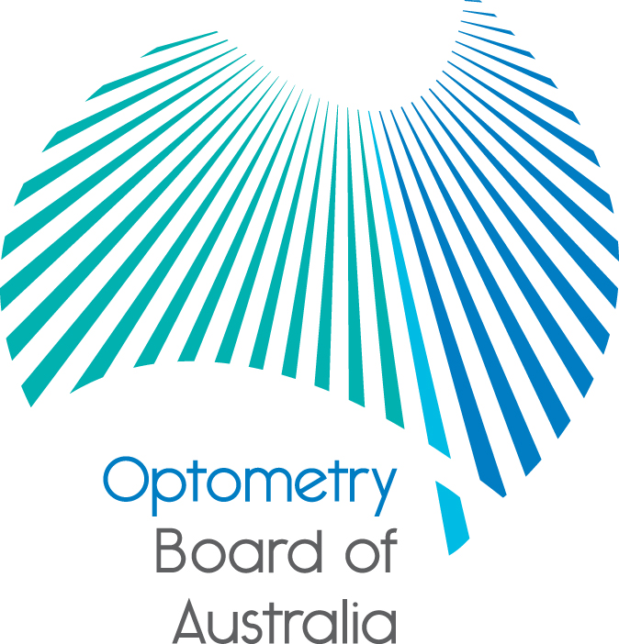
Communiqué: Optometry Board of Australia

November and December 2018 meetings
The 98th and 99th meetings of the Optometry Board of Australia (the Board) were held on 22 November 2018 and 13 December 2018 in Melbourne. The Board’s recent newsletter distributed on 13 November 2018 covered matters considered by the Board at its meeting on 25 October 2018.
This communiqué outlines the issues and decisions from these meetings as well as other points of interest. We publish it on our website and email it to a broad range of stakeholders. Please forward it to your colleagues and employees who may be interested.
Extension of AHPRA contract with Optometry Australia for CPD accreditation services
On the Board’s recommendation, the Australian Health Practitioner Regulation Agency (AHPRA), as the contracting entity, entered into a one-year contract extension with Optometry Australia for the provision of continuing professional development (CPD) accreditation services until 30 November 2019. The Board will review these arrangements before the new expiry date.
Review of registration standards – CPD
A letter co-signed by some National Boards including the Optometry Board has been sent to the COAG Health Council. Among other matters relevant to other National Boards, the letter contained recommendations in relation to the revised CPD registration standards that apply to optometrists, with a recommended implementation date of 1 December 2020 for optometrists. Guidance materials are being developed by the AHPRA Registration Review Working Group to support practitioners’ understanding and compliance with revised registration standards.
Two practitioner representatives from the Board, Associate Professor Ann Webber and Associate Professor Daryl Guest, will participate on the Continuing Professional Development Implementation Reference Group in 2019. This reference group will provide input into the development of cross-professional CPD guidance materials with specific considerations for different professions.
Endorsement for scheduled medicines registration standard and guidelines
The Board has considered a revision of its list of topical medicines in Appendix B of its Endorsement for scheduled medicines registration standard and guidelines to include ganciclovir, as an alternative to aciclovir on the Board’s list of Schedule 4 topical anti-infectives medicines. Other amendments were also considered including administrative corrections to Appendices A and B in the Board’s Guidelines for use of scheduled medicines. Before finalising any amendments, the Board will undertake consultation with its key stakeholders.
Revisions to return to practice guidance materials
The Board considered a draft suite of materials relating to return to practice guidance specific to optometrists. These materials will be further reviewed by the practitioners on the Board’s Return to Practice Working Group and its Registration and Notifications Committee. The documents within the suite comprise revised FAQ on recency of practice, an information sheet on returning to practice or significantly changing a practitioner’s scope of practice, revisions to the supervised practice plan and professional development plan templates. They also include a return to practice application checklist and tips when taking a break from practice. Feedback will be sought from external stakeholders during the second quarter of 2019.

Social research project
AHPRA, through its Communications Team, recently completed a social research project to test the perception of stakeholder sentiment including practitioners towards AHPRA and the National Boards. The findings will help build strategies for developing stronger confidence in AHPRA’s communications and engagement with the public, practitioners and other stakeholders.
The Board wishes to thank the many anonymous respondents who participated in the surveys by documenting their experiences. The Board would like to assure respondents that their responses and concerns have been reviewed by Board members. The Board hopes that subsequent changes in notifications systems have enabled concerns with procedural fairness to be addressed.
Information paper for the public about regulation of optometrists
The Board is preparing a plain English information document to increase awareness and understanding of what to expect when members of the public consult an optometrist and how the Board regulates optometrists to promote public safety. Following feedback from AHPRA’s Community Reference Group, it is expected that this document will be published before the end of this financial year.
Appointment of Board members to Committees
The Board has finalised the appointment of its members to the following Committees of the Board:
Registration and Notifications Committee – Chair: Ian Bluntish, Members: Judith Hannan and Adrienne Farago
Policy and Education Committee – Chair: Ann Webber, Members: Carla Abbott, Adrienne Farago, Daryl Guest and Rosemary Knight
Finance and Risk Committee – Chair: Anthony Evans, Members: Stuart Aamodt and Ann Webber
Scheduled Medicines Advisory Committee – Chair: Daryl Guest
Paramedics: Welcome to the National Scheme!
On Saturday 1 December 2018, the National Registration and Accreditation Scheme (National Scheme) reached a milestone with paramedicine becoming the sixteenth regulated health profession.

Reflecting on the milestone, Paramedicine Board of Australia Chair Associate Professor Stephen Gough ASM noted that it was the culmination of many years of debate, deliberation and sustained effort by the paramedic profession to join a national regulatory scheme that has patient safety at its heart.

‘While paramedics have always had the patient at the centre of everything they do – showing compassion, understanding and empathy to those they provide care – the past two decades have also seen the profession grow in complexity; paramedics are now working in a range of roles and environments, using sophisticated treatments and technology, to provide world-class services to Australian communities.

‘Regulating paramedicine under the National Scheme acknowledges the critical role paramedics play in our health system and recognises paramedics as registered health professionals,’ Associate Professor Gough said.

1 December 2018 also marks just over two years since the COAG Health Council announced its intention to regulate the paramedicine profession, with the inaugural National Board appointed in October 2017.

Over this time, stakeholders across the profession, including governments, jurisdictional ambulance services, and private and volunteer organisations, have worked together to make sure that all eligible paramedics are well prepared for regulation.

Since registration opened at the beginning of September 2018, over 17,000 paramedics have applied for registration.

Find out more about paramedicine on the Paramedicine Board of Australia’s website.

Do you practise under the name published on the online Register of practitioners?
Governments recently consulted on possible changes to the Health Practitioner Regulation National Law (National Law), which would allow AHPRA and National Boards to publish on the online Register of practitioners, the names that registered health practitioners use in practice and not just their legal name.
The national online Register of practitioners is a vital part of Australia’s system of regulating optometrists to support patient safety. Each registered health profession publishes registration information about practitioners on the online register. The public and employers can look up the names of all health practitioners who are registered to practise. The registers also provide important information about limits or restrictions placed on the way a registered health practitioner is allowed to practise.
The national online registers must remain an authoritative and trusted source of information about health practitioners. Consumers rely on them for accurate and up to date information to inform their healthcare decision-making and employers rely on them to validate their employees’ registration status.
AHPRA and the Optometry Board know some optometrists practise the profession using a name that is different from their legally recognised name published on the register (an alias).
AHPRA has asked governments to consider changes to the National Law that would enable registered health practitioners to nominate one or more aliases to be recorded on the public register. Governments recently consulted on this, among a range of other possible amendments to the National Law.
AHPRA believes that recording additional names (or aliases) on the register will help to inform and protect the public, by making it easier to identify a practitioner who may be registered and able to practise but who is not using their legal name.
There are some operational and practical issues that will need to be considered if governments make this change. A clear definition of an ‘alias’ is required, so practitioners’ reporting obligations to AHPRA and the Board are clear. AHPRA and National Boards will need to consider what information practitioners will need to provide about their use of aliases in practice and whether any verification of this will be necessary to protect the validity of the register. Finally, there may be risks of unintended consequences - including whether publishing aliases could be used for commercial gain or benefits that are not related to public information and protection, which is the focus of the National Law.
AHPRA and the Board will keep practitioners and the public informed of any changes to the law and reporting requirements.
AHPRA and National Boards welcome release of the Accreditation Systems Review final report
AHPRA and National Boards have welcomed the publication of the Independent Accreditation Systems Review final report.
The Independent Accreditation Systems Review’s (the Review) final report makes significant, far reaching recommendations to reform the accreditation system for regulated health professions in Australia. It proposes recommendations which range from relatively uncontentious and which the National Scheme bodies generally support, to those which are significantly more complex and contentious.
Health Ministers commissioned the Review following a review of the National Scheme as a whole.
For more information read the statement on the AHPRA website.
Are your contact details up to date?
It is important that your contact details are up to date to receive renewal reminders from AHPRA and information from the Board. You can check your details via the Login icon at the top right of the AHPRA website. Email accounts need to be set to receive communications from AHPRA and the Board to avoid misdirection to an account junk box.

Follow AHPRA on social media
Connect with AHPRA on Facebook, Twitter or LinkedIn to receive information about important topics for your profession and participate in the discussion.

Further information
We publish a range of information about registration and our expectations of you as an optometrist on our website at www.optometryboard.gov.au or www.ahpra.gov.au.
For more details or help with questions about your registration, notifications or other matters relevant to the National Scheme, refer to information published on www.ahpra.gov.au or contact AHPRA, send an online enquiry form or call on 1300 419 495.
Ian Bluntish
Chair, Optometry Board of Australia
December 2018

The Optometry Board of Australia is the regulator of optometrists in Australia and acts to protect the public by ensuring that suitably qualified and competent optometrists are registered. The Board is responsible for developing registration standards, codes and guidelines for optometrists and managing notifications (complaints)* about optometrists and optometry students. The Board does this through its powers under the Health Practitioner Regulation National Law, as in force in each state and territory, and the National Registration and Accreditation Scheme, supported by the Australian Health Practitioner Regulation Agency (AHPRA). The Board’s work in regulating Australia’s optometrists in the public interest is underpinned by regulatory principles, which encourage a responsive, risk-based approach to regulation.
*Except in NSW and Qld which have co-regulatory arrangements.

