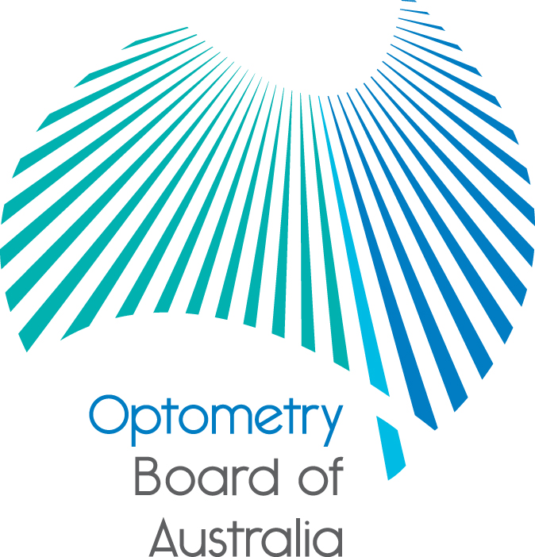
Communiqué: Optometry Board of Australia

December 2017 meeting
The 89th meeting of the Optometry Board of Australia (the Board) was held on 14 December 2017 at the Australian Health Practitioner Regulation Agency (AHPRA) National office in Melbourne.
This communiqué outlines the issues and decisions from this meeting as well as other points of interest. We publish it on our website and email it to a broad range of stakeholders. Please forward it to your colleagues and employees who may be interested.
Upcoming call for applications for appointment to the Scheduled Medicines Advisory Committee of the Optometry Board of Australia
The Board will soon invite applications from registered optometrists and medical practitioners seeking appointment to the Scheduled Medicines Advisory Committee (the Committee) in early 2018. The Board will be seeking:
- an optometrist (who holds an endorsement for scheduled medicines)
- an optometrist (who holds an endorsement for scheduled medicines and is an academic/educator in optometry), and
- a medical practitioner (who practises as an ophthalmologist).
The Board regulates more than 5400 registered optometrists. The primary role of the Board is to protect the public. The role of the Committee is to advise the Board on matters with respect to the administration or prescribing of scheduled medicines by optometrists for diagnostic or therapeutic purposes.
More information about the role, selection criteria and application process will be made available in the candidate information pack on the committee recruitment page of the AHPRA website.
Update on the review of the continuing professional development standard and guidelines
The Board is progressing its review of its registration standard and related guidelines for continuing professional development jointly with a number of other AHPRA National Boards.
The Board is aiming to consult publicly on the revised standard and guidelines in early 2018 and when ready will advise its stakeholders and publish the public consultation documents on the Board’s Current Consultations page.
Any changes made to the approved revised registration standard and guidelines after public consultation will have a period of transition to support the profession in adapting to these changes.
Community Reference Group communiqués available
The Community Reference Group (CRG) has a number of roles, including providing feedback, information and advice on strategies for building better knowledge in the community about health practitioner regulation, but also advising AHPRA and National Boards on how to better understand, and most importantly, meet, community needs.
The CRG last met on 23 November 2017 and communiqués from the group’s meetings are published on the Communiqués page after each of its meetings.

Stakeholders meet to work on how to support responsible advertising in healthcare
National Boards, AHPRA and stakeholders interested in how regulated health services are advertised previously met at a multi-profession stakeholder forum, to discuss how to advertise responsibly and comply with the National Law advertising requirements.
The forum provided information about new developments involving the broader Advertising compliance and enforcement strategy including the practical resources that have been developed to support people to comply with advertising obligations. Stakeholders also debated current issues with representatives from consumer organisations, professional associations, insurers and other regulators, in addition to Board members and AHPRA staff.
A number of resources from the forum are now available for practitioners and stakeholders to help them advertise responsibly, including a highlight video from the day and full videos of presenters and panel discussions, as well as a full report of the day.
For more information read this news item.
Are your contact details up to date?
It is important that your contact details are up to date to receive renewal reminders from AHPRA and information from the Board. You can check your details via the Login icon at the top right of the AHPRA website. Email accounts need to be set to receive communications from AHPRA and the Board to avoid misdirection to an account junk box.
Follow AHPRA on social media
Connect with AHPRA on Facebook,Twitter or LinkedIn to receive information about important topics for your profession and participate in the discussion.

Further information
We publish a range of information about registration and our expectations of you as an optometrist on our website at www.optometryboard.gov.au or www.ahpra.gov.au.
For more details or help with questions about your registration, notifications or other matters relevant to the National Scheme, refer to information published on www.ahpra.gov.au or contact AHPRA, send an online enquiry form or call on 1300 419 495.
Ian Bluntish
Chair, Optometry Board of Australia
December 2017

The Optometry Board of Australia is the regulator of optometrists in Australia and acts to protect the public by ensuring that suitably qualified and competent optometrists are registered. The Board is responsible for developing registration standards, codes and guidelines for optometrists and managing notifications (complaints)* about optometrists and optometry students. The Board does this through its powers under the Health Practitioner Regulation National Law, as in force in each state and territory, and the National Registration and Accreditation Scheme, supported by the Australian Health Practitioner Regulation Agency (AHPRA). The Board’s work in regulating Australia’s optometrists in the public interest is underpinned by regulatory principles, which encourage a responsive, risk-based approach to regulation.
*Except in NSW and Qld which have co-regulatory arrangements.

The Health Practitioner Regulation National Law, as in force in each state and territory.

