Optometry Registrant Data: March 2013

Published April 2013

Introduction
The functions of the Optometry Board of Australia include:
- registering optometrists and students
- developing standards, codes and guidelines for the optometry profession
- handling notifications, complaints, investigations and disciplinary hearings
- assessing overseas trained practitioners who wish to practise in Australia
- approving accreditation standards and accredited courses of study.

The Board’s functions are supported by Australian Health Practitioner Regulation Agency (AHPRA). For information about legislation governing our operations see AHPRA's Legislation & Publications at http://www.ahpra.gov.au/Legislation-and-Publications.aspx

The Board has analysed its registration data and produced a number of statistical breakdowns about registrants to share with the profession and community. The Board shares these breakdowns regularly.

For more information on optometry registration, please see the Board’s website:
www.optometryboard.gov.au/Registration.aspx

Index of Tables
Optometrists: State and territory by registration type 2
Optometrists: Age by registration type 3
Optometrists: Gender by state and territory by registration type 4
Optometrists: Endorsement type by state and territory 4

Optometrists: State and territory by registration type
State | General | Non-practising | Total | % By State
ACT | 73 |  | 73 | 1.58%
NSW | 1,539 | 43 | 1,582 | 34.19%
NT | 27 | 1 | 28 | 0.61%
QLD | 901 | 12 | 913 | 19.73%
SA | 239 | 1 | 240 | 5.19%
TAS | 82 |  | 82 | 1.77%
VIC | 1,154 | 26 | 1,180 | 25.5%
WA | 362 | 6 | 368 | 7.95%
Not Stated | 127 | 34 | 161 | 3.48%
Total | 4,504 | 123 | 4,627

% By state and territory
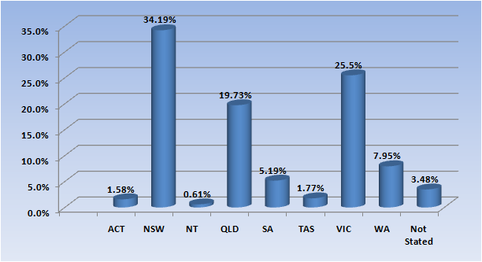

Optometrists: Age by registration type
Age Group | General | Non-practising | Total | % By Age Group
21 - 25 | 293 | 1 | 294 | 6.35%
26 - 30 | 657 | 7 | 664 | 14.35%
31 - 35 | 632 | 16 | 648 | 14.0%
36 - 40 | 589 | 21 | 610 | 13.18%
41 - 45 | 600 | 22 | 622 | 13.44%
46 - 50 | 515 | 11 | 526 | 11.37%
51 - 55 | 529 | 20 | 549 | 11.87%
56 - 60 | 408 | 11 | 419 | 9.06%
61 - 65 | 169 | 5 | 174 | 3.76%
66 - 70 | 64 | 5 | 69 | 1.49%
71 - 75 | 31 | 2 | 33 | 0.71%
76 - 80 | 10 | 1 | 11 | 0.24%
81 - 85 | 4 |  | 4 | 0.09%
86 + | 2 | 1 | 3 | 0.06%
Not Stated | 1 |  | 1 | 0.02%
Total | 4,504 | 123 | 4,627

% By age
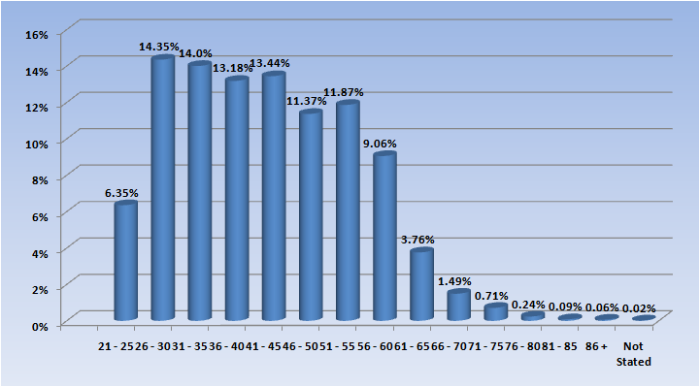

Optometrists: Gender by state and territory by registration type
Sex | State | General | Non-practising | Total Count | % By Sex By State
Female | ACT | 38 |  | 38 | 0.82%
Female | NSW | 799 | 20 | 819 | 17.7%
Female | NT | 15 | 1 | 16 | 0.35%
Female | QLD | 417 | 5 | 422 | 9.12%
Female | SA | 63 | 1 | 64 | 1.38%
Female | TAS | 27 |  | 27 | 0.58%
Female | VIC | 594 | 14 | 608 | 13.14%
Female | WA | 146 | 5 | 151 | 3.26%
Female | Not Stated | 52 | 17 | 69 | 1.49%
Female | Sub total | 2,151 | 63 | 2,214 | 47.85%
Male | ACT | 35 |  | 35 | 0.76%
Male | NSW | 733 | 23 | 756 | 16.34%
Male | NT | 12 |  | 12 | 0.26%
Male | QLD | 481 | 7 | 488 | 10.55%
Male | SA | 72 |  | 72 | 1.56%
Male | TAS | 54 |  | 54 | 1.17%
Male | VIC | 557 | 12 | 569 | 12.3%
Male | WA | 214 | 1 | 215 | 4.65%
Male | Not Stated | 73 | 17 | 90 | 1.95%
Male | Sub total | 2,231 | 60 | 2,291 | 49.51%
Not Stated | NSW | 7 |  | 7 | 0.15%
Not Stated | QLD | 3 |  | 3 | 0.06%
Not Stated | SA | 104 |  | 104 | 2.25%
Not Stated | TAS | 1 |  | 1 | 0.02%
Not Stated | VIC | 3 |  | 3 | 0.06%
Not Stated | WA | 2 |  | 2 | 0.04%
Not Stated | Not Stated | 2 |  | 2 | 0.04%
Not Stated | Sub total | 122 |  | 122 | 2.64%
Total |  | 4,504 | 123 | 4,627

Optometrists: Endorsement type by state/territory
Endorsement | ACT | NSW | NT | QLD | SA | TAS | VIC | WA | Not Stated | Total
Scheduled Medicines | 21 | 307 | 9 | 253 | 95 | 54 | 636 | 92 | 20 | 1,487
Total | 21 | 307 | 9 | 253 | 95 | 54 | 636 | 92 | 20 | 1,487

