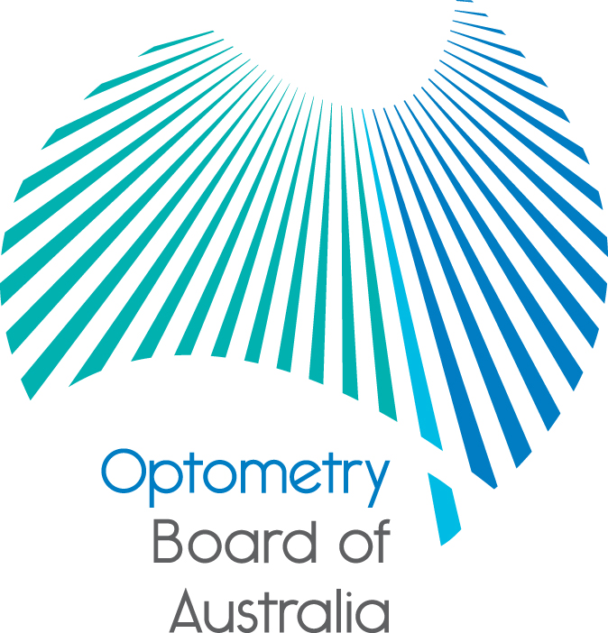
Communiqué: Optometry Board of Australia

November 2017 meeting
The 88th meeting of the Optometry Board of Australia (the Board) was held on 23 November 2017 at the Australian Health Practitioner Regulation Agency (AHPRA) National office in Melbourne.
This communiqué outlines the issues and decisions from this meeting as well as other points of interest. We publish it on our website and email it to a broad range of stakeholders. Please forward it to your colleagues and employees who may be interested.
Board members at SA Blue Sky Congress 2017
The Board Chair provided a short presentation at the SA Blue Sky Conference on 11 November 2017. The presentation provided a snapshot of the profession, an update on the Board’s current work and upcoming opportunities for becoming a Board member. The Board Chair and a number of representatives of the Board also held an exhibit space on 10-11 November 2017, providing opportunities for delegates to meet Board members and to ask questions about the Board’s work.
The Annual Report is now available
The 2016/17 Annual Report produced by AHPRA and the 14 National Boards is a comprehensive record of the National Registration and Accreditation Scheme (the National Scheme) for the year ending 30 June 2017. The Board works in partnership with AHPRA to regulate optometrists across Australia.
Over the past year, registration with the Optometry Board of Australia (the Board) grew by 3.9% to 5,343 optometrists. This contingent now comprises 0.8% of all health practitioners in the National Scheme. More information can be found on the AHPRA Annual Report website.
Quarterly registration data released
The Board publishes quarterly data profiling Australia’s optometry workforce, including a number of statistical breakdowns about registrants. The Board has released its March 2017 registration data on the Board’s Statistics page.
Are your contact details up to date?
It is important that your contact details are up to date to receive renewal reminders from AHPRA and information from the Board. You can check your details via the Login icon at the top right of the AHPRA website. Email accounts need to be set to receive communications from AHPRA and the Board to avoid misdirection to an account junk box.
Follow AHPRA on social media
Connect with AHPRA on Facebook,Twitter or LinkedIn to receive information about important topics for your profession and participate in the discussion.

Further information
We publish a range of information about registration and our expectations of you as an optometrist on our website at www.optometryboard.gov.au or www.ahpra.gov.au.
For more details or help with questions about your registration, notifications or other matters relevant to the National Scheme, refer to information published on www.ahpra.gov.au or contact AHPRA, send an online enquiry form or call on 1300 419 495.
Ian Bluntish
Chair, Optometry Board of Australia
November 2017

The Optometry Board of Australia is the regulator of optometrists in Australia and acts to protect the public by ensuring that suitably qualified and competent optometrists are registered. The Board is responsible for developing registration standards, codes and guidelines for optometrists and managing notifications (complaints)* about optometrists and optometry students. The Board does this through its powers under the Health Practitioner Regulation National Law, as in force in each state and territory, and the National Registration and Accreditation Scheme, supported by the Australian Health Practitioner Regulation Agency (AHPRA). The Board’s work in regulating Australia’s optometrists in the public interest is underpinned by regulatory principles, which encourage a responsive, risk-based approach to regulation.
*Except in NSW and Qld which have co-regulatory arrangements.

