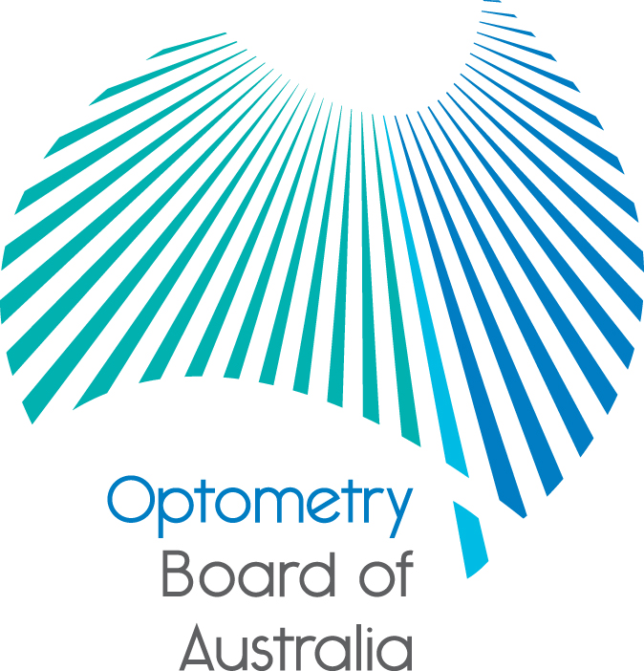
Communiqué
The 74th meeting of the Optometry Board of Australia (the Board) was held on 26 May 2016 at the Australian Health Practitioner Regulation Agency (AHPRA) national office in Melbourne.
This communiqué outlines the issues and decisions from this meeting as well as other points of interest. We publish it on our website and email it to a broad range of stakeholders. Please forward it to your colleagues and employees who may be interested.
Refreshed Registration and Notification Committee
The Board’s Registration and Notification Committee (RNC) is the delegated authority to consider matters relating to individual optometrists, from a complex registration matter or consideration of a notification (complaint) about an optometrist. It is a six-member committee made up of both practitioner and community members.
Expressions of interest from several interested optometrists for the three non-Board member positions were received and the Board has appointed the following people in addition to the existing Board members:
Non-Board members
- Nancy Atkinson – practitioner member
- Stephanie Bahler – practitioner member
- Neville Turner – practitioner member
Board members
- Ian Bluntish – Chair, practitioner member
- Adrienne Farago ‒ community member
- Ann Webber – practitioner member
Whenever expressions of interest are called for by the Board, the information is available on the Committee member recruitment page on AHPRA’s website.
Graduate video launch
As part of its communications strategy, the Board has developed a short animated information video targeted to optometry students and graduates available via the Board’s website. The video aims to raise the awareness of optometry students and graduates of the standards they need to meet to become registered and the professional standard obligations to maintain registration. The video also refers to relevant guidelines and highlights the information available on the Board’s website. Access to the video is also via the AHPRA YouTube channel that contains other relevant information about the regulation of health professionals.
Health profession agreement and fees
The health profession agreement between the Board and the Australian Health Practitioner Regulation Agency (AHPRA) is being finalised and will be published on the Board’s website soon. It sets out the services that AHPRA will provide to support the Board to regulate optometry practitioners. The agreement includes information about the Board’s financial operations and fees.
National restrictions library
Restrictions (conditions and undertakings) are a primary regulatory tool used to protect the public. Regulators place restrictions on registration as necessary in the course of an investigation and/or disciplinary procedure or as a result of a disciplinary procedure. Restrictions may also be imposed at the time of registration or renewal of registration, for various reasons.
A National Restrictions Library has been developed to provide a consolidated structure for common restrictions used across the regulatory functions of all of the National Boards and to support:
- consistency in recommendations from AHPRA to the National Boards and delegates
- consistency in the restrictions appearing on the national public register of health practitioners, and
- a best practice approach to monitoring compliance with restrictions.
More information about the National Restrictions Library, including a copy of the contents, can be found on AHPRA’s website.
Family and domestic violence – Queensland and Victoria state reports released
The Board is committed to being part of the solution to major health and social problems as best we can within our mandate as a regulator of optometrists.
Everyone should feel safe at home. Tragically, many people across Australia face great danger at home from the people closest to them. Family violence can affect anyone, regardless of their gender, age, ethnicity or sexuality and it not only impacts on victims, but also their family, friends and the wider society. Health practitioners who often work closely with families could also be in the right place at the right time to help families who fall victim to such violence.
Two significant reports have recently been released on this issue, including one in Queensland and one in Victoria.
The Queensland Government commissioned a special taskforce to conduct an inquiry into domestic and family violence in Queensland. The Taskforce’s report ‘Not Now Not Ever - putting an End to Domestic and Family Violence in Queensland’ made 140 recommendations to Queensland and national bodies, including three to the National Scheme.
In Victoria, the Royal Commission into Family Violence released its report and recommendations on how Victoria's response to family violence can be improved. The Commission's 227 recommendations are directed at improving the foundations of the current system, seizing opportunities to transform the way that we respond to family violence, and building the structures that will guide and oversee a long-term reform program that deals with all aspects of family violence. Though there were no specific recommendations directed towards AHPRA or National Boards, several referenced the important role the health system and health professional bodies have to play in influencing child safeguarding and in improving the accreditation and training for health practitioners in this area.
Quarterly registration data released to end of March 2016
The National Board has released its quarterly registration data. The National Registration and Accreditation Scheme requires that information about every registered health practitioner in Australia is published on a single national register of practitioners. For the first time, it is possible to produce accurate reports on the number of practitioners registered in each profession in Australia.
Further information
We publish a range of information about registration and our expectations of you as an optometrist on our website at www.optometryboard.gov.au or www.ahpra.gov.au.
Ian Bluntish
Chair
Optometry Board of Australia
22 June 2016

