

Optometry Board of Australia

Registrant Data

Reporting period: 1 April 2017 – 30 June 2017

Table of contents
Introduction 3
Principal Place of Practice 4
1. Registration Type 4
2. Endorsements 5
Age Group 6
3. Registration Type 6
Gender 8
3. Registration Type 8
4. Percentage 8

Introduction
The role of the Optometry Board of Australia (the Board) include:
- registering optometrists and students
- developing standards, codes and guidelines for the optometry profession
- handling notifications, complaints, investigations and disciplinary hearings
- overseeing the assessment of overseas trained practitioners who wish to practise in Australia, and
- approving accreditation standards and accredited courses of study.
The Board’s functions are supported by the Australian Health Practitioner Regulation Agency (AHPRA). For information about legislation governing our operations see About AHPRA at www.ahpra.gov.au/About-AHPRA/What-We-Do/Legislation.aspx.
The Board has analysed its registration data and produced a number of statistical breakdowns about registrants to share with the profession and community. The Board shares these breakdowns regularly.
For more information on optometry registration, please see the Board’s website: www.optometryboard.gov.au/Registration.aspx

Principal Place of Practice
- Registration Type
  - Registration type by principal place of practice
Registration Type | Registration Sub-type | ACT | NSW | NT | QLD | SA | TAS | VIC | WA | No PPP | Total
General |  | 74 | 1,764 | 29 | 1,040 | 292 | 92 | 1,359 | 415 | 102 | 5,167
Limited | Postgraduate training or supervised practice |  |  |  | 1 |  |  |  | 1 |  | 2
Limited | Teaching or research |  | 2 |  |  |  |  |  |  |  | 2
Non-practising |  | 2 | 41 |  | 20 | 2 | 1 | 37 | 6 | 63 | 172
Total |  | 76 | 1,807 | 29 | 1,061 | 294 | 93 | 1,396 | 422 | 165 | 5,343

  - Registration type by principal place of practice percentages

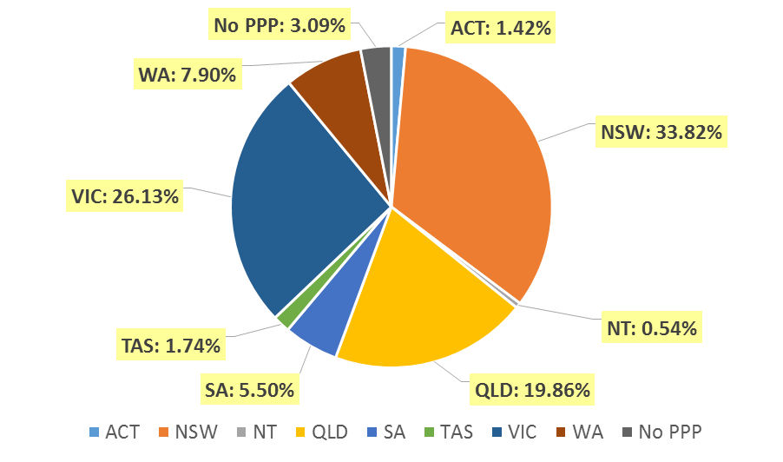

- Endorsements
  - Endorsements
Endorsement | ACT | NSW | NT | QLD | SA | TAS | VIC | WA | No PPP | Total
Scheduled Medicines* | 38 | 707 | 21 | 522 | 182 | 68 | 952 | 202 | 25 | 2,717
% of general registrants who are endorsed | 51.4% | 40.1% | 72.4% | 50.2% | 62.3% | 73.9% | 70.1% | 48.7% | 24.5% | 52.6%

  - Endorsements by age group
Age Group | Scheduled Medicines* | % of General Registrants
U - 25 | 296 | 99.3%
25 - 29 | 791 | 94.7%
30 - 34 | 446 | 65.0%
35 - 39 | 333 | 51.7%
40 - 44 | 248 | 42.5%
45 - 49 | 208 | 34.4%
50 - 54 | 137 | 29.0%
55 - 59 | 151 | 29.4%
60 - 64 | 70 | 20.1%
65 - 69 | 31 | 26.5%
70 - 74 | 5 | 10.6%
75 - 79 | 1 | 5.6%
80+
Total | 2,717 | 52.6%

*Only Optometrists holding general registration are eligible to hold the scheduled medicines endorsement.

Age Group
- Registration type
  - Registrants by age group
Age Group | General | Limited |  | Non-practising | Total
Age Group | General | Postgraduate training or supervised practice | Teaching or research | Non-practising | Total
U - 25 | 298 |  |  |  | 298
25 - 29 | 835 | 1 |  | 7 | 843
30 - 34 | 686 | 1 | 2 | 25 | 714
35 - 39 | 644 |  |  | 19 | 663
40 - 44 | 583 |  |  | 22 | 605
45 - 49 | 604 |  |  | 23 | 627
50 - 54 | 473 |  |  | 19 | 492
55 - 59 | 513 |  |  | 25 | 538
60 - 64 | 348 |  |  | 17 | 365
65 - 69 | 117 |  |  | 8 | 125
70 - 74 | 47 |  |  | 4 | 51
75 - 79 | 18 |  |  | 2 | 20
80+ | 1 |  |  | 1 | 2
Total | 5,167 | 2 | 2 | 172 | 5,343

  - Registrants age group, by principal place of practice
Age Group | ACT | NSW | NT | QLD | SA | TAS | VIC | WA | No PPP | Total
U - 25 | 5 | 109 | 1 | 64 | 24 | 6 | 64 | 24 | 1 | 298
25 - 29 | 13 | 272 | 7 | 146 | 61 | 6 | 287 | 45 | 6 | 843
30 - 34 | 8 | 221 | 1 | 149 | 36 | 10 | 227 | 45 | 17 | 714
35 - 39 | 12 | 242 | 3 | 123 | 33 | 3 | 164 | 63 | 20 | 663
40 - 44 | 13 | 171 | 5 | 133 | 35 | 13 | 163 | 53 | 19 | 605
45 - 49 | 12 | 205 | 2 | 137 | 28 | 11 | 144 | 61 | 27 | 627
50 - 54 | 4 | 152 |  | 119 | 13 | 11 | 123 | 46 | 24 | 492
55 - 59 | 6 | 221 | 8 | 85 | 28 | 19 | 101 | 42 | 28 | 538
60 - 64 | 3 | 153 |  | 66 | 27 | 7 | 74 | 20 | 15 | 365
65 - 69 |  | 42 | 1 | 23 | 5 | 4 | 34 | 11 | 5 | 125
70 - 74 |  | 10 | 1 | 15 | 3 | 3 | 9 | 8 | 2 | 51
75 - 79 |  | 9 |  | 1 | 1 |  | 5 | 3 | 1 | 20
80+ |  |  |  |  |  |  | 1 | 1 |  | 2
Total | 76 | 1,807 | 29 | 1,061 | 294 | 93 | 1,396 | 422 | 165 | 5,343

  - Registrants by age group

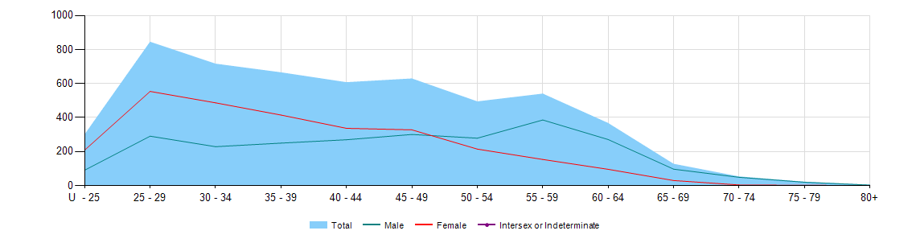

Gender
- Registration Type
  - Gender by state and territory by registration type
Gender | Registration Type | Sub Type |  | ACT | NSW | NT | QLD | SA | TAS | VIC | WA | No PPP | Total
Female | General |  |  | 40 | 974 | 14 | 535 | 142 | 36 | 739 | 190 | 50 | 2,720
Female | Limited | Postgraduate training or supervised practice |  |  |  |  | 1 |  |  |  | 1 |  | 2
Female | Limited | Teaching or Research |  |  | 1 |  |  |  |  |  |  |  | 1
Female | Non-practising |  |  | 1 | 22 |  | 9 | 2 |  | 23 | 5 | 34 | 96
Total Female |  |  |  | 41 | 997 | 14 | 545 | 144 | 36 | 762 | 196 | 84 | 2,819
Male | General |  |  | 34 | 790 | 15 | 505 | 150 | 56 | 620 | 225 | 52 | 2,447
Male | Limited |  | Teaching or research |  | 1 |  |  |  |  |  |  |  | 1
Male | Non-practising |  |  | 1 | 19 |  | 11 |  | 1 | 14 | 1 | 29 | 76
Total Male |  |  |  | 35 | 810 | 15 | 516 | 150 | 57 | 634 | 226 | 81 | 2,524
Total |  |  |  | 76 | 1,807 | 29 | 1,061 | 294 | 93 | 1,396 | 422 | 165 | 5,343

Percentage
  - Registrants by gender percentages
Gender | ACT | NSW | NT | QLD | SA | TAS | VIC | WA | No PPP | Total
Female | 53.9% | 55.2% | 48.3% | 51.4% | 49.0% | 38.7% | 54.6% | 46.4% | 50.9% | 52.8%
Male | 46.1% | 44.8% | 51.7% | 48.6% | 51.0% | 61.3% | 45.4% | 53.6% | 49.1% | 47.2%

