

Optometry Board of Australia

Registrant Data

Reporting period: 1 April 2016 – 30 June 2016

Table of contents
Introduction 3
Principal Place of Practice 4
1. Registration Type 4
2. Endorsements 5
Age Group 6
Gender 8
3. Registration Type 8
4. Percentage 8

Introduction
The role of the Optometry Board of Australia (the Board) include:
- registering optometrists and students
- developing standards, codes and guidelines for the optometry profession
- handling notifications, complaints, investigations and disciplinary hearings
- overseeing the assessment of overseas trained practitioners who wish to practise in Australia, and
- approving accreditation standards and accredited courses of study.
The Board’s functions are supported by the Australian Health Practitioner Regulation Agency (AHPRA). For information about legislation governing our operations see About AHPRA at http://www.ahpra.gov.au/About-AHPRA/What-We-Do/Legislation.aspx.
The Board has analysed its registration data and produced a number of statistical breakdowns about registrants to share with the profession and community. The Board shares these breakdowns regularly.
For more information on optometry registration, please see the Board’s website: http://www.optometryboard.gov.au/Registration.aspx

Principal Place of Practice
- Registration Type
  - Registration type by principal place of practice
Registration Type | Registration Sub-type | ACT | NSW | NT | QLD | SA | TAS | VIC | WA | No PPP | Total
General |  | 74 | 1,699 | 29 | 1,017 | 278 | 84 | 1,280 | 407 | 109 | 4,977
Limited | Postgraduate training or supervised practice |  |  |  | 1 |  |  |  | 1 |  | 2
Limited | Teaching or research |  | 3 |  |  |  |  |  |  |  | 3
Non-practising |  | 1 | 41 | 1 | 13 | 2 | 1 | 35 | 9 | 57 | 160
Total |  | 75 | 1,743 | 30 | 1,031 | 280 | 85 | 1,315 | 417 | 166 | 5,142

  - Registration type by principal place of practice percentages

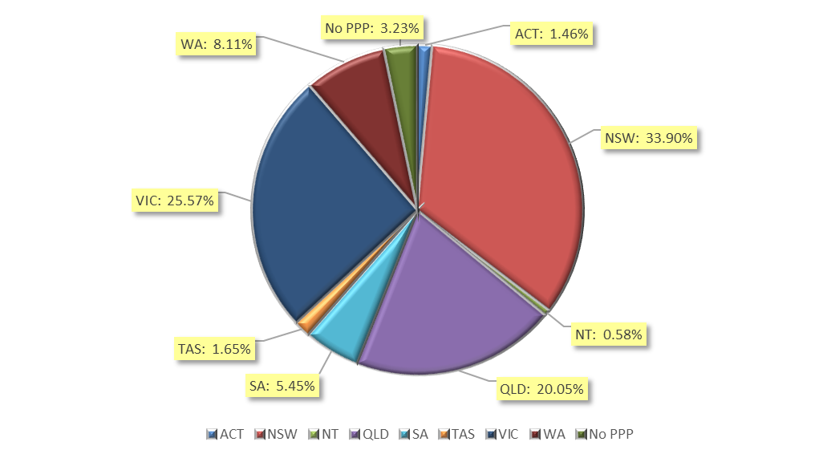

- Endorsements
  - Endorsements
Endorsement | ACT | NSW | NT | QLD | SA | TAS | VIC | WA | No PPP | Total
Scheduled Medicines* | 32 | 596 | 19 | 469 | 157 | 60 | 839 | 189 | 26 | 2,387
% of general registrants who are endorsed | 43.2% | 35.1% | 65.5% | 46.1% | 56.5% | 71.4% | 65.5% | 46.4% | 23.9% | 48%

  - Endorsements by age group
Age Group | Scheduled Medicines* | % of General Registrants
U - 25 | 295 | 99.3%
25 - 29 | 673 | 89.9%
30 - 34 | 405 | 58.6%
35 - 39 | 282 | 43.8%
40 - 44 | 216 | 37.9%
45 - 49 | 172 | 28.8%
50 - 54 | 127 | 28%
55 - 59 | 129 | 24.5%
60 - 64 | 59 | 20.4%
65 - 69 | 27 | 27%
70 - 74 | 2 | 5%
75 - 79 |  | 0%
80+ |  | 0%
Total | 2,387 | 48%

*Only Optometrists holding general registration are eligible to hold the scheduled medicines endorsement.

Age Group
- Registration type
  - Registrants by age group
Age Group | General | Limited |  | Non-practising | Total
Age Group | General | Postgraduate training or supervised practice | Teaching or research | Non-practising | Total
U - 25 | 297 |  |  |  | 297
25 - 29 | 749 | 1 | 2 | 13 | 765
30 - 34 | 691 |  | 1 | 20 | 712
35 - 39 | 644 | 1 |  | 16 | 661
40 - 44 | 570 |  |  | 21 | 591
45 - 49 | 598 |  |  | 22 | 620
50 - 54 | 454 |  |  | 19 | 473
55 - 59 | 526 |  |  | 20 | 546
60 - 64 | 289 |  |  | 15 | 304
65 - 69 | 100 |  |  | 7 | 107
70 - 74 | 40 |  |  | 3 | 43
75 - 79 | 17 |  |  | 3 | 20
80+ | 2 |  |  | 1 | 3
Total | 4,977 | 2 | 3 | 160 | 5,142

  - Registrants age group, by principal place of practice
Age Group | ACT | NSW | NT | QLD | SA | TAS | VIC | WA | No PPP | Total
U - 25 | 4 | 112 | 1 | 73 | 30 | 2 | 52 | 22 | 1 | 297
25 - 29 | 13 | 239 | 4 | 134 | 43 | 5 | 270 | 48 | 9 | 765
30 - 34 | 7 | 234 | 5 | 136 | 39 | 9 | 213 | 51 | 18 | 712
35 - 39 | 12 | 233 | 2 | 126 | 26 | 8 | 170 | 63 | 21 | 661
40 - 44 | 15 | 170 | 5 | 138 | 35 | 10 | 150 | 50 | 18 | 591
45 - 49 | 10 | 214 | 1 | 136 | 29 | 10 | 132 | 62 | 26 | 620
50 - 54 | 3 | 130 | 6 | 112 | 16 | 9 | 129 | 40 | 28 | 473
55 - 59 | 7 | 245 | 4 | 83 | 26 | 21 | 91 | 43 | 26 | 546
60 - 64 | 3 | 117 | 1 | 58 | 25 | 4 | 66 | 18 | 12 | 304
65 - 69 | 1 | 32 |  | 22 | 4 | 3 | 32 | 9 | 4 | 107
70 - 74 |  | 7 | 1 | 11 | 4 | 3 | 6 | 9 | 2 | 43
75 - 79 |  | 10 |  | 1 | 2 |  | 4 | 2 | 1 | 20
80+ |  |  |  | 1 | 1 | 1 |  |  |  | 3
Total | 75 | 1,743 | 30 | 1,031 | 280 | 85 | 1,315 | 417 | 166 | 5,142

  - Registrants by age group

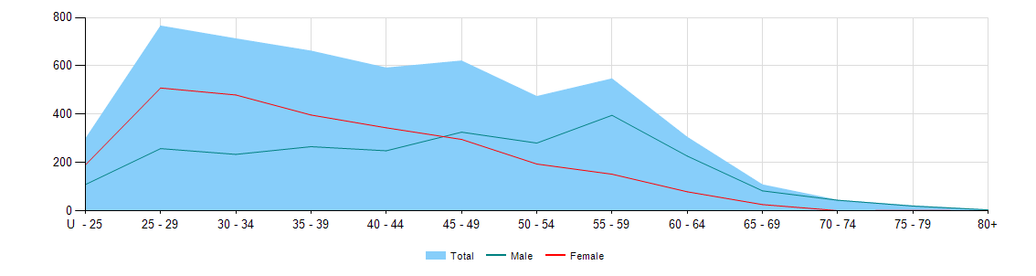

Gender
- Registration Type
  - Gender by state and territory by registration type
Gender | Registration Type | Sub Type | ACT | NSW | NT | QLD | SA | TAS | VIC | WA | No PPP | Total
Female | General |  | 42 | 926 | 14 | 513 | 125 | 28 | 684 | 180 | 54 | 2,566
Female | Limited | Postgraduate training or supervised practice |  |  |  | 1 |  |  |  | 1 |  | 2
Female | Limited | Teaching or Research |  | 3 |  |  |  |  |  |  |  | 3
Female | Non-practising |  |  | 20 | 1 | 6 | 2 | 1 | 21 | 6 | 30 | 87
Total Female |  |  | 42 | 949 | 15 | 520 | 127 | 29 | 705 | 187 | 84 | 2,658
Male | General |  | 32 | 773 | 15 | 504 | 153 | 56 | 596 | 227 | 55 | 2,411
Male | Non-practising |  | 1 | 21 |  | 7 |  |  | 14 | 3 | 27 | 73
Total Male |  |  | 33 | 794 | 15 | 511 | 153 | 56 | 610 | 230 | 82 | 2,484
Total |  |  | 75 | 1,743 | 30 | 1,031 | 280 | 85 | 1,315 | 417 | 166 | 5,142

Percentage
  - Registrants by gender percentages
Gender | ACT | NSW | NT | QLD | SA | TAS | VIC | WA | No PPP | Total
Female | 56% | 54.4% | 50% | 50.4% | 45.4% | 34.1% | 53.6% | 44.8% | 50.6% | 51.7%
Male | 44% | 45.6% | 50% | 49.6% | 54.6% | 65.9% | 46.4% | 55.2% | 49.4% | 48.3%

