

Optometry Board of Australia

Registrant Data

Reporting period: 1 October 2016 – 31 December 2016

Table of contents
Introduction 3
Principal Place of Practice 4
1. Registration Type 4
2. Endorsements 5
Age Group 6
Gender 8
3. Registration Type 8
4. Percentage 8

Introduction
The role of the Optometry Board of Australia (the Board) include:
- registering optometrists and students
- developing standards, codes and guidelines for the optometry profession
- handling notifications, complaints, investigations and disciplinary hearings
- overseeing the assessment of overseas trained practitioners who wish to practise in Australia, and
- approving accreditation standards and accredited courses of study.
The Board’s functions are supported by the Australian Health Practitioner Regulation Agency (AHPRA). For information about legislation governing our operations see About AHPRA at http://www.ahpra.gov.au/About-AHPRA/What-We-Do/Legislation.aspx.
The Board has analysed its registration data and produced a number of statistical breakdowns about registrants to share with the profession and community. The Board shares these breakdowns regularly.
For more information on optometry registration, please see the Board’s website: http://www.optometryboard.gov.au/Registration.aspx

Principal Place of Practice
- Registration Type
  - Registration type by principal place of practice
Registration Type | Registration Sub-type | ACT | NSW | NT | QLD | SA | TAS | VIC | WA | No PPP | Total
General |  | 71 | 1,727 | 29 | 1,045 | 293 | 93 | 1,358 | 413 | 105 | 5,134
Limited | Postgraduate training or supervised practice |  |  |  | 1 |  |  |  | 1 |  | 2
Limited | Teaching or research |  | 1 |  |  |  |  |  |  |  | 1
Non-practising |  | 2 | 39 |  | 22 | 2 | 1 | 35 | 9 | 66 | 176
Total |  | 73 | 1,767 | 29 | 1,068 | 295 | 94 | 1,393 | 423 | 171 | 5,313

  - Registration type by principal place of practice percentages

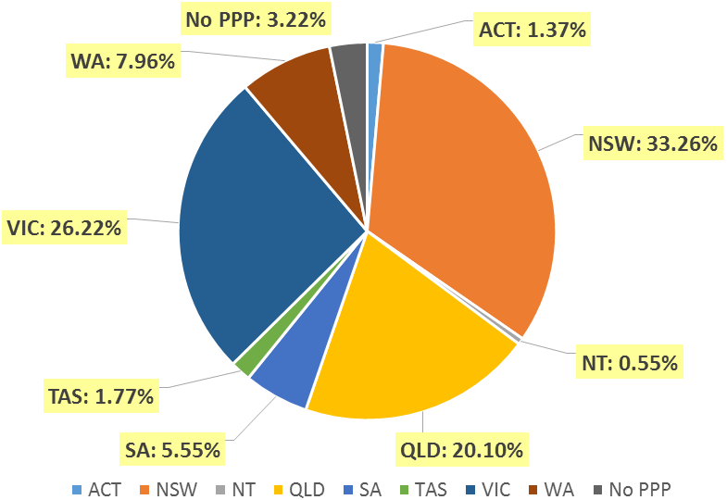

- Endorsements
  - Endorsements
Endorsement | ACT | NSW | NT | QLD | SA | TAS | VIC | WA | No PPP | Total
Scheduled Medicines* | 35 | 638 | 21 | 515 | 178 | 67 | 937 | 197 | 27 | 2,615
% of general registrants who are endorsed | 49.3% | 36.9% | 72.4% | 49.3% | 60.8% | 72.0% | 69.0% | 47.7% | 25.7% | 50.9%

  - Endorsements by age group
Age Group | Scheduled Medicines* | % of General Registrants
U - 25 | 324 | 99.4%
25 - 29 | 741 | 92.2%
30 - 34 | 439 | 62.7%
35 - 39 | 309 | 48.2%
40 - 44 | 241 | 41.1%
45 - 49 | 194 | 32.6%
50 - 54 | 130 | 28%
55 - 59 | 139 | 27.3%
60 - 64 | 65 | 19.8%
65 - 69 | 27 | 25%
70 - 74 | 5 | 10.6%
75 - 79 | 1 | 5%
80+
Total | 2,615 | 50.9%

*Only Optometrists holding general registration are eligible to hold the scheduled medicines endorsement.

Age Group
- Registration type
  - Registrants by age group
Age Group | General | Limited |  | Non-practising | Total
Age Group | General | Postgraduate training or supervised practice | Teaching or research | Non-practising | Total
U - 25 | 326 |  |  |  | 326
25 - 29 | 804 | 1 |  | 10 | 815
30 - 34 | 700 | 1 | 1 | 20 | 722
35 - 39 | 641 |  |  | 19 | 660
40 - 44 | 587 |  |  | 24 | 611
45 - 49 | 596 |  |  | 23 | 619
50 - 54 | 464 |  |  | 22 | 486
55 - 59 | 510 |  |  | 24 | 534
60 - 64 | 328 |  |  | 18 | 346
65 - 69 | 108 |  |  | 8 | 116
70 - 74 | 47 |  |  | 4 | 51
75 - 79 | 20 |  |  | 2 | 22
80+ | 3 |  |  | 2 | 5
Total | 5,134 | 2 | 1 | 176 | 5,313

  - Registrants age group, by principal place of practice
Age Group | ACT | NSW | NT | QLD | SA | TAS | VIC | WA | No PPP | Total
U - 25 | 6 | 101 | 2 | 82 | 34 | 5 | 74 | 20 | 2 | 326
25 - 29 | 11 | 260 | 6 | 134 | 52 | 7 | 292 | 46 | 7 | 815
30 - 34 | 6 | 220 | 2 | 150 | 36 | 9 | 226 | 52 | 21 | 722
35 - 39 | 12 | 237 | 3 | 123 | 31 | 6 | 162 | 65 | 21 | 660
40 - 44 | 15 | 171 | 4 | 141 | 34 | 14 | 164 | 48 | 20 | 611
45 - 49 | 11 | 214 | 2 | 132 | 28 | 10 | 134 | 64 | 24 | 619
50 - 54 | 2 | 140 | 2 | 117 | 14 | 9 | 128 | 45 | 29 | 486
55 - 59 | 7 | 228 | 6 | 84 | 28 | 20 | 95 | 40 | 26 | 534
60 - 64 | 3 | 139 |  | 63 | 27 | 6 | 72 | 22 | 14 | 346
65 - 69 |  | 38 | 1 | 24 | 4 | 4 | 32 | 9 | 4 | 116
70 - 74 |  | 9 | 1 | 16 | 4 | 3 | 8 | 8 | 2 | 51
75 - 79 |  | 10 |  | 1 | 2 |  | 5 | 3 | 1 | 22
80+ |  |  |  | 1 | 1 | 1 | 1 | 1 |  | 5
Total | 73 | 1,767 | 29 | 1,068 | 295 | 94 | 1,393 | 423 | 171 | 5,313

  - Registrants by age group

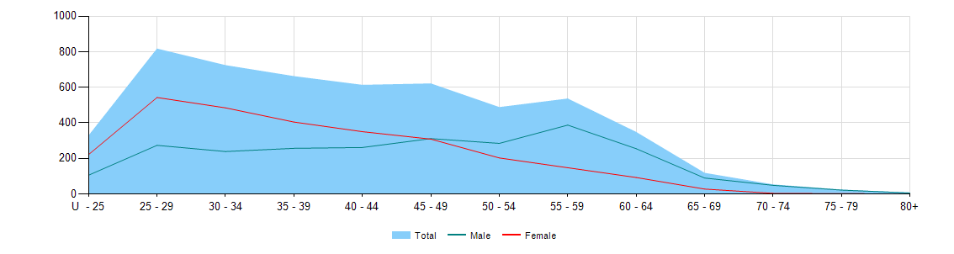

Gender
- Registration Type
  - Gender by state and territory by registration type
Gender | Registration Type | Sub Type | ACT | NSW | NT | QLD | SA | TAS | VIC | WA | No PPP | Total
Female | General |  | 39 | 946 | 14 | 535 | 140 | 34 | 737 | 186 | 52 | 2,683
Female | Limited | Postgraduate training or supervised practice |  |  |  | 1 |  |  |  | 1 |  | 2
Female | Limited | Teaching or Research |  | 1 |  |  |  |  |  |  |  | 1
Female | Non-practising |  | 1 | 19 |  | 10 | 2 |  | 22 | 6 | 35 | 95
Total Female |  |  | 40 | 966 | 14 | 546 | 142 | 34 | 759 | 193 | 87 | 2,781
Male | General |  | 32 | 781 | 15 | 510 | 153 | 59 | 621 | 227 | 53 | 2,451
Male | Non-practising |  | 1 | 20 |  | 12 |  | 1 | 13 | 3 | 31 | 81
Total Male |  |  | 33 | 801 | 15 | 522 | 153 | 60 | 634 | 230 | 84 | 2,532
Total |  |  | 73 | 1,767 | 29 | 1,068 | 295 | 94 | 1,393 | 423 | 171 | 5,313

Percentage
  - Registrants by gender percentages
Gender | ACT | NSW | NT | QLD | SA | TAS | VIC | WA | No PPP | Total
Female | 54.8% | 54.7% | 48.3% | 51.1% | 48.1% | 36.2% | 54.5% | 45.6% | 50.9% | 52.3%
Male | 45.2% | 45.3% | 51.7% | 48.9% | 51.9% | 63.8% | 45.5% | 54.4% | 49.1% | 47.7%

