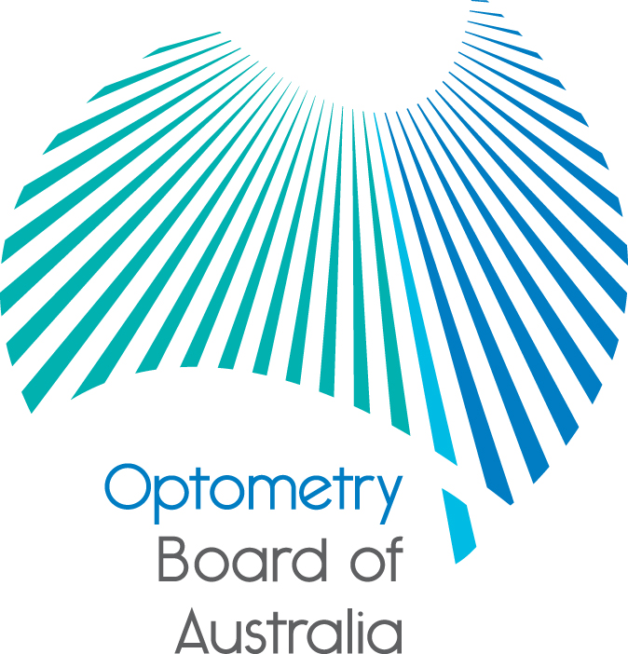
Communiqué
The 71st meeting of the Optometry Board of Australia (the Board) was held on 25 February 2016 at the Australian Health Practitioner Regulation Agency (AHPRA) national office in Melbourne.
This communiqué outlines the issues and decisions from this meeting as well as other points of interest. We publish it on our website and email it to a broad range of stakeholders. Please forward it to your colleagues and employees who may be interested.
2016 Revised guidelines on the prescription of optical appliances
The Board approved a revised guideline on the prescription of optical appliances and will be published in the near future on the Board’s website prior to taking effect in mid 2016. The revision of the guideline was in response to a scheduled review of the guideline resulting in minimal changes.
Approved providers of accredited CPD activities
The Board recently granted approved Continuing Professional Development (CPD) provider status to Flinders University and the Cornea and Contact Lens Society of Australia (CCLSA). This enables those organisations to assign CPD points to CPD activities and acknowledges they are now recognised as meeting the criteria for CPD activity accreditation.
Continuing professional development (CPD) is essential for optometrists to maintain their competence and develop the personal qualities required to deliver the quality of care that the community expects. Optometrists are reminded that they can meet their CPD registration standard obligations by undertaking accredited or non-accredited activities, or a combination of both.
Board regulatory work plan
The Board undertook a review of its regulatory work plan in conjunction with the February meeting. Issues discussed included:
- developing a better understanding of the needs of stakeholders with regards to the regulation of optometrists, and
- opportunities for greater cross professional regulatory work that maintains the profession specific optometry input into the regulation of registered health professionals.
Call for applications – Registration and Notification Committee
The Optometry Board of Australia (the Board) will be seeking applications from experienced practising optometrists for appointment to its Registration and Notifications Committee to assist the Board in its primary role of protecting the public.
The functions of the Committee include:
- making decisions in relation to registration and notification matters
- providing professional and practitioner input to AHPRA about optometry registration and notification matters, and
- making recommendations and providing advice to the Board.
Further information is available on the Board’s website and applications close on Monday 11 April 2016.
Local data summaries from a National Scheme
The National Boards and AHPRA have published reports for each state and territory on the National Scheme.
The reports provide a unique insight on local outcomes within a scheme for which the core focus is protection of the public. They are for the 2014/15 year of the scheme.
The summaries provide local data on registration types, notifications (complaints) and mandatory notifications for the regulated health professions, for each state and territory.
National awareness campaign
You may have seen the beginning of the AHPRA national awareness campaign. Know your obligations, the first of three phases, directed at employers of health practitioners, launched at the close of last year. The message has been shared over social media through targeted ads resulting in a doubling of our online community.
The next phase of the campaign is targeted at practitioners. Under the headline of The not-so-small print, practitioners are encouraged to stay up to date with regulation changes as they occur, and to be aware of their obligations as registered practitioners. Advertisements will be rolled out later this month across a mix of social media, industry publications and newsletters.
The final phase will be directed at the public to increase awareness of the national register of practitioners.
Further information
We publish a range of information about registration and our expectations of you as an optometrist on our website at www.optometryboard.gov.au or www.ahpra.gov.au.
Ian Bluntish
Chair
Optometry Board of Australia
29 March 2016

