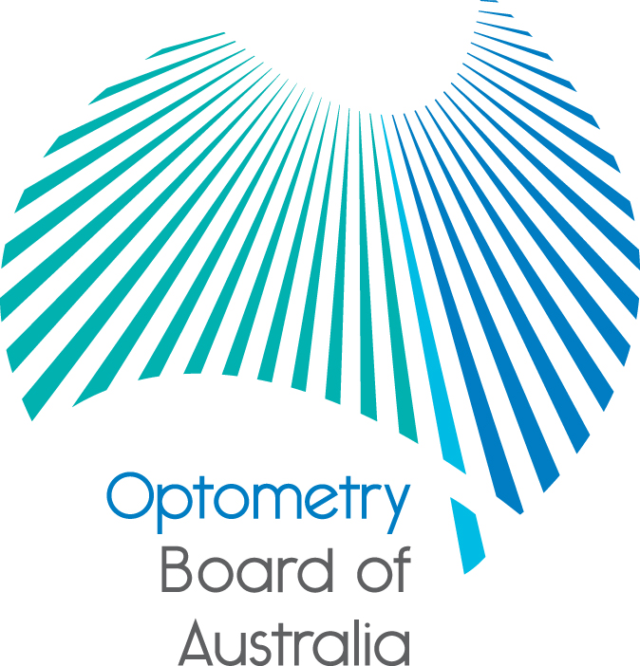
Communiqué
The 76th meeting of the Optometry Board of Australia (the Board) was held on 28 July 2016 at the Australian Health Practitioner Regulation Agency (AHPRA) national office in Melbourne.
This communiqué outlines the issues and decisions from this meeting as well as other points of interest. We publish it on our website and email it to a broad range of stakeholders. Please forward it to your colleagues and employees who may be interested.
Call for applications for appointment to the Scheduled Medicines Expert Committee
AHPRA and 14 health profession boards (National Boards), work together to deliver the National Registration and Accreditation scheme.
AHPRA is seeking expressions of interest from suitably qualified and experienced persons to be appointed to a Scheduled Medicines Expert Committee (the Expert Committee).
The role of the Expert Committee is to advise the National Boards on policy related to the use of scheduled medicines, including matters relevant to National Boards developing submissions for endorsements for scheduled medicines for consideration by the Australian Health Workforce Ministerial Council.
Appointments are for a period of up to three years and are expected to start in late September 2016.
Applications close Monday 22 August 2016.
For more information on the role and the application process, you can download the application guide and application forms from the AHPRA website.
OCANZ Accreditation standards and evidence guide for entry-level optometry programs
The Optometry Council of Australia and New Zealand (OCANZ) completed public consultation on its review of accreditation standards for Accreditation Standards and Evidence Guide for Entry-Level Optometry Program. The Board approved the standards at its July meeting.
The Accreditation Standards and Evidence Guide for Entry-Level Optometry Program will take effect on 1 January 2017. The Accreditation manual for optometry programs in Australia and New Zealand – Part 2 – Standards April 2006 remain in effect until then.
The new standards will be available on the Board’s accreditation webpage soon.
New quarterly performance reports available
The January to March 2016 quarterly performance reports for AHPRA and the National Boards are now available.
The reports, which are part of an ongoing drive by AHPRA and the National Boards to increase their accountability and transparency, include data specific to each state and territory.
Each report covers AHPRA and the National Boards’ main areas of activity:
- managing applications for registration as a health practitioner
- managing notifications about the health, performance and conduct of registered health practitioners and offences against the National Law, and
- monitoring health practitioners and students with restrictions on their registration.

The reports are available on the AHPRA website’s Statistics page.
To provide feedback on the reports please email: reportingfeedback@ahpra.gov.au.
Further information
We publish a range of information about registration and our expectations of you as an optometrist on our website at www.optometryboard.gov.au or www.ahpra.gov.au.
For more details or help with questions about your registration, notifications or other matters relevant to the National Registration and Accreditation Scheme, refer to information published on www.ahpra.gov.au or contact AHPRA, send an online enquiry form or call on 1300 419 495.
Ian Bluntish
Chair
Optometry Board of Australia

9 August 2016

The Optometry Board of Australia is the regulator of optometrists in Australia and acts to protect the public by ensuring that suitably qualified and competent optometrists are registered. The Board is responsible for developing registration standards, codes and guidelines for optometrists and managing notifications (complaints)* about optometrists and optometry students. The Board does this through its powers under the Health Practitioner Regulation National Law, as in force in each state and territory, and the National Registration and Accreditation Scheme, supported by the Australian Health Practitioner Regulation Agency (AHPRA). The Board’s work in regulating Australia’s optometrists in the public interest is underpinned by regulatory principles, which encourage a responsive, risk-based approach to regulation.
*Except in NSW and QLD which have co-regulatory arrangements.

