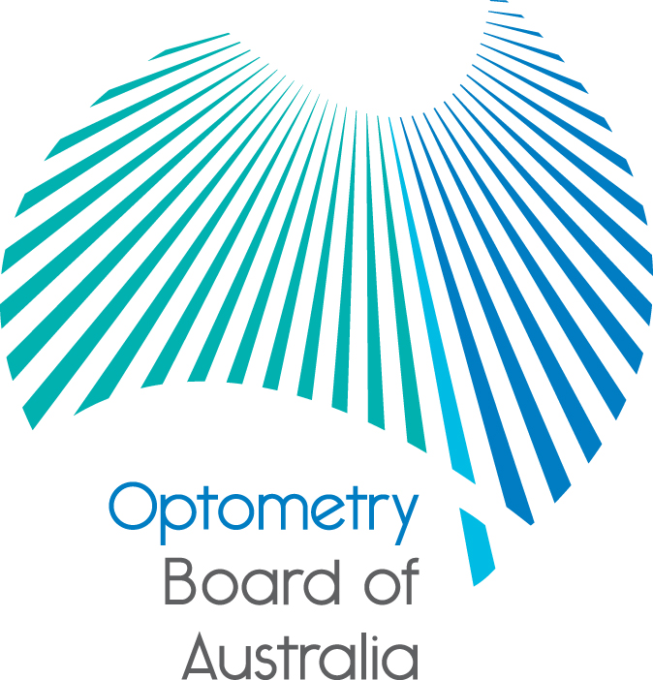
Communiqué: Optometry Board of Australia

July 2018 meeting
The 94th meeting of the Optometry Board of Australia (the Board) was held on 26 July 2018 at the Australian Health Practitioner Regulation Agency (AHPRA) National office in Melbourne.
This communiqué outlines the issues and decisions from this meeting as well as other points of interest. We publish it on our website and email it to a broad range of stakeholders. Please forward it to your colleagues and employees who may be interested.
Closing the gap by 2031: A shared commitment
The National Registration and Accreditation Scheme Statement of Intent (Statement of Intent) was launched on Thursday 5 July. The statement is signed by 37 health organisations, including leading Aboriginal and Torres Strait Islander health organisations and entities working to implement Australia’s regulation scheme for health practitioners; AHPRA, all National Boards and all accreditation authorities.
The work to develop the Statement of Intent and its associated work is being led by the National Scheme Aboriginal and Torres Strait Islander Health Strategy Group and coordinated by AHPRA on behalf of the National Scheme. It has been developed in close partnership with a range of Aboriginal and Torres Strait Islander organisations and experts.
The group shares a commitment to ensuring that Aboriginal and Torres Strait Islander Peoples have access to health services that are culturally safe and free from racism so that they can enjoy a healthy life, equal to that of other Australians, enriched by a strong living culture, dignity and justice.
To help achieve this, the group is focusing on:
- a culturally safe health workforce supported by nationally consistent standards, codes and guidelines across all professions in the National Scheme
- using our leadership and influence to achieve reciprocal goals
- increased Aboriginal and Torres Strait Islander Peoples’ participation in the registered health workforce
- greater access for Aboriginal and Torres Strait Islander Peoples to culturally safe services of health professions regulated under the National Scheme, and
- increased participation across all levels of the National Scheme.
Find out more about the National Scheme Aboriginal and Torres Strait Islander Health Strategy Group, which led this work.
- Read the Statement of Intent
- Read AHPRA’s Reconciliation Action Plan
True partnership recognised through AHPRA and Victoria Police MOU
AHPRA and Victoria Police have announced a Memorandum of Understanding (MOU) to enable greater cooperation which will see the public better protected.
The MOU is the first of its kind between AHPRA and a police force. It recognises the cooperation already in place between the two agencies. It establishes procedures for timely and appropriate information sharing, within the law, where AHPRA or Victoria Police discover certain information in the course of their investigations.
The MOU provides a mechanism for the release of information by AHPRA when it identifies information relating to criminal offences, including physical harm, sexual offending, production of exploitative material and/or drug offences.
Victoria Police will also be better placed to share information with AHPRA about practitioners who they suspect may pose a risk of substantial harm to the public or individuals posing as registered health practitioners when they are not.
The MOU recognises the learning that came from the Chaperone Review, a report into the use of chaperones to protect patients. The report stated that where there are allegations of indecent or sexual assault there needed to be greater clarity around whether AHPRA contacts the police or relies on the notifier (the person who makes the complaint) to do so. The report also considered it was important that AHPRA was kept aware of developments in police investigations, which may trigger the need to review risk and take immediate action on a registered health practitioner’s ability to practise their profession.
The MOU is available to the public.
Are your contact details up to date?
It is important that your contact details are up to date to receive renewal reminders from AHPRA and information from the Board. You can check your details via the Login icon at the top right of the AHPRA website. Email accounts need to be set to receive communications from AHPRA and the Board to avoid misdirection to an account junk box.
Follow AHPRA on social media
Connect with AHPRA on Facebook, Twitter or LinkedIn to receive information about important topics for your profession and participate in the discussion.
Further information
We publish a range of information about registration and our expectations of you as an optometrist on our website at www.optometryboard.gov.au or www.ahpra.gov.au.
For more details or help with questions about your registration, notifications or other matters relevant to the National Scheme, refer to information published on www.ahpra.gov.au or contact AHPRA, send an online enquiry form or call on 1300 419 495.
Ian Bluntish
Chair, Optometry Board of Australia
July 2018

The Optometry Board of Australia is the regulator of optometrists in Australia and acts to protect the public by ensuring that suitably qualified and competent optometrists are registered. The Board is responsible for developing registration standards, codes and guidelines for optometrists and managing notifications (complaints)* about optometrists and optometry students. The Board does this through its powers under the Health Practitioner Regulation National Law, as in force in each state and territory, and the National Registration and Accreditation Scheme, supported by the Australian Health Practitioner Regulation Agency (AHPRA). The Board’s work in regulating Australia’s optometrists in the public interest is underpinned by regulatory principles, which encourage a responsive, risk-based approach to regulation.
*Except in NSW and Qld which have co-regulatory arrangements.

