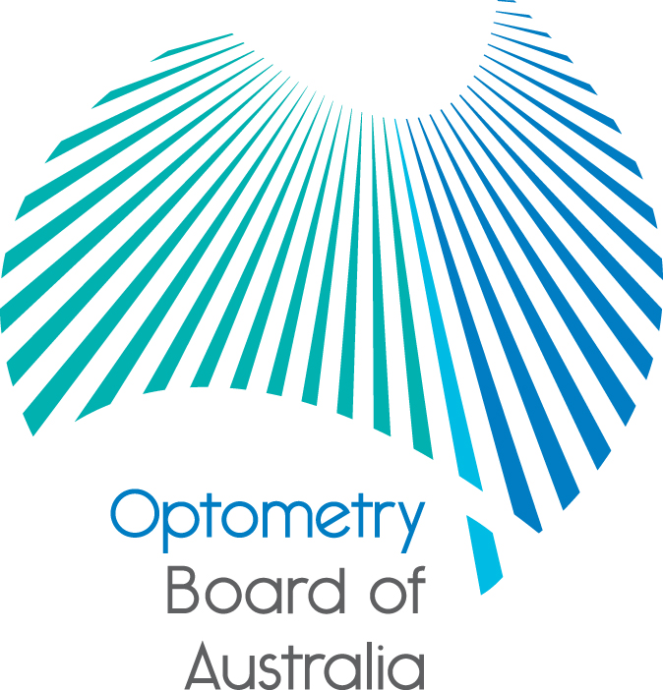
Communiqué: Optometry Board of Australia

March 2018 meeting
The 91st meeting of the Optometry Board of Australia (the Board) was held on 29 March 2018 at the Australian Health Practitioner Regulation Agency (AHPRA) National office in Melbourne.
This communiqué outlines the issues and decisions from this meeting as well as other points of interest. We publish it on our website and email it to a broad range of stakeholders. Please forward it to your colleagues and employees who may be interested.
Survey on professional behaviour

We’re interested in finding out more about how optometrists look for information about professional behaviour. Please take our anonymous survey to let us know.

We will use the information collected to inform our work on policies, codes and guidelines and how we communicate with practitioners about their professional obligations.
Public consultation for the revised continuing professional development standard and guidelines
The Board has published a consultation paper on the review of the revised Continuing professional development registration standard and related guidelines. The revised registration standard sets out the Board’s minimum requirements for continuing professional development (CPD) for optometrists.
With other National Boards, the Board has reviewed the current registration standard and related guidelines in keeping with good regulatory practice and seeks feedback from the profession, stakeholders and the community on the proposed revised CPD registration standard and related guidelines.
Public consultation will close on 4 May 2018. To view the consultation paper, please see the Current Consultations page. For more information see the Board’s news item.
Stakeholder information forum held about the CPD consultation
The Board also held a stakeholder information forum on the CPD consultation on 28 March 2018. The forum was an opportunity to for key stakeholders to learn and ask questions about the public consultation and the proposed changes to the current registration standard and related guidelines. It was also an opportunity for the Board to listen to any stakeholder concerns.
Scheduled review of accreditation assignments
National Boards and AHPRA have started a process to consider accreditation arrangements from mid-2019, when the current term of assignment of accreditation functions ends.
The Health Practitioner Regulation National Law sets out the accreditation functions in the National Registration and Accreditation Scheme; these include developing accreditation standards, accrediting programs of study against approved accreditation standards and assessing overseas qualified practitioners.
Public consultation on the existing accreditation arrangements is expected to start during April 2018 for around four weeks. More information will be published on the AHPRA and National Board websites in coming weeks.
Read the full news item.
Early Career Optometrists SA networking event: Meet the Board
On 25 July 2018 the Board will co-host a networking event with Early Career Optometrists South Australia at the Royal Society for the Blind in Adelaide.
The Board and Early Career Optometrists SA would like to invite all early career optometrists, final year university students and other interested Optometry SA members to attend.
The event offers attendees the opportunity to:
- meet the Board, including community Board members
- learn the difference between the role of the Board and the role of Optometry Australia (OA)
- learn about the future of optometry regulation in Australia and what OA and optometrists can do
- ask the Board questions, and
- learn how to become a Board or Committee member.

For more information, see the Board’s news item.

Applications for appointment to the Optometry Board of Australia now closed
There was recently a call for applications for appointment to the Board due to the scheduled expiry of terms of appointment. All appointments are made by the COAG Health Council for up to three years. The call for applications closed on Friday 9 March 2018.
If you would like to receive direct notice of future Board or committee vacancies when they are advertised, please contact Statutory Appointments from your preferred email address, advising which professions or roles you are interested in.

AHPRA and the Boards release their annual report

AHPRA and the Board have released their annual report revealing how the Board has worked to protect the public in 2016/17. The report is a comprehensive record of the National Registration and Accreditation Scheme for the 12 months to 30 June 2017.

The 2016/17 Annual Report: AHPRA and the National Boards, and the Optometry regulation at work in Australia 2016/17 summary are available to download.
National Scheme Aboriginal and Torres Strait Islander health strategy presentation
The Board had a presentation on the National Scheme Aboriginal and Torres Strait Islander health strategy and endorsed their Statement of Intent. National Boards and AHPRA have committed to an Aboriginal and Torres Strait Islander health strategy with the vision of:
Patient safety for Aboriginal and Torres Strait Islander peoples is the norm. We recognise that:
- patient safety includes the inextricably linked elements of clinical and cultural safety, and
- this link must be defined by Aboriginal and Torres Strait Islander Peoples.

Communiqués from the Aboriginal and Torres Strait Islander Health Strategy Group can be found on the AHPRA website.
Are your contact details up to date?
It is important that your contact details are up to date to receive renewal reminders from AHPRA and information from the Board. You can check your details via the Login icon at the top right of the AHPRA website. Email accounts need to be set to receive communications from AHPRA and the Board to avoid misdirection to an account junk box.
Follow AHPRA on social media
Connect with AHPRA on Facebook, Twitter or LinkedIn to receive information about important topics for your profession and participate in the discussion.
Further information
We publish a range of information about registration and our expectations of you as an optometrist on our website at www.optometryboard.gov.au or www.ahpra.gov.au.
For more details or help with questions about your registration, notifications or other matters relevant to the National Scheme, refer to information published on www.ahpra.gov.au or contact AHPRA, send an online enquiry form or call on 1300 419 495.
Ian Bluntish
Chair, Optometry Board of Australia
April 2018

The Optometry Board of Australia is the regulator of optometrists in Australia and acts to protect the public by ensuring that suitably qualified and competent optometrists are registered. The Board is responsible for developing registration standards, codes and guidelines for optometrists and managing notifications (complaints)* about optometrists and optometry students. The Board does this through its powers under the Health Practitioner Regulation National Law, as in force in each state and territory, and the National Registration and Accreditation Scheme, supported by the Australian Health Practitioner Regulation Agency (AHPRA). The Board’s work in regulating Australia’s optometrists in the public interest is underpinned by regulatory principles, which encourage a responsive, risk-based approach to regulation.
*Except in NSW and Qld which have co-regulatory arrangements.

