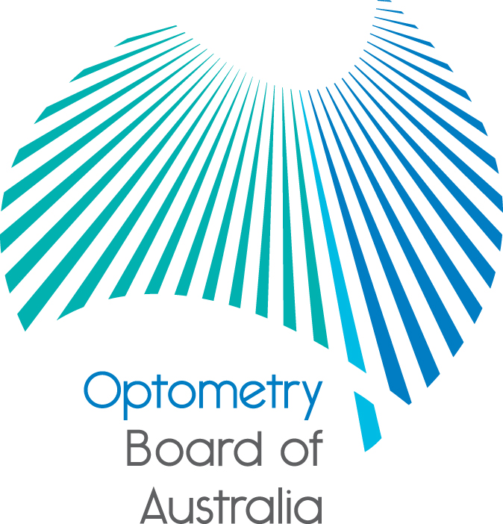
Communiqué

October 2016 meeting of the Optometry Board of Australia
The 77th meeting of the Optometry Board of Australia (the Board) was held on 27 October 2016 at the AHPRA National office in Melbourne.
This communiqué outlines the issues and decisions from this meeting as well as other points of interest. We publish it on our website and email it to a broad range of stakeholders. Please forward it to your colleagues and employees who may be interested.
Scheduled medicines
The Board agreed to proceed to public consultation in the coming weeks on a revised Endorsement for scheduled medicines registration standard and revised Guidelines for the use of scheduled medicines.
The revised registration standard and guidelines do not alter the scope of the endorsement but seek to clarify and refine wording and reduce the use of inconsistent language. The Board welcomes feedback from all stakeholders as part of this process.
When it is released the consultation document will be made available on the Current consultations page on the Board’s website.
Reminder: renewal of registration for 2016/17
The Board reminds optometrists to renew their registration by 30 November 2016, the registration expiry date for general and non-practising registration. Under the National Law, optometrists are responsible for renewing their registration on time each year. Renewal applications received within a month after the expiry date will incur a late fee.
Optometrists who do not renew registration within one month of their registration expiry date must have their name removed from the national register of practitioners. Their registration will lapse and they will not be able to practise or work as an optometrist in Australia until a new application for registration is approved.
A series of reminders to renew are being sent to practitioners by AHPRA, on behalf of the Board. The email reminders include links to online renewal and to a video which explains the process.
The Board encourages optometrists to renew online and reminds them to make sure AHPRA has their current contact information to receive future email and hard copy reminders to renew.
Graduate applications for registration: Final-year students can apply online now
Optometry students who will soon complete an approved program of study can go online now to apply for registration before they graduate.
Graduates need to be registered as an optometrist with the Board before they start practising and must meet the Board’s registration requirements.
The online graduate application service on the AHPRA website helps to smooth the path from study to work by enabling students to apply for registration four to six weeks before completing their course. All applicants must send some supporting documents to AHPRA by mail to complete their application.

Australian Health Ministers’ communiqués published
The Australian Health Workforce Ministerial Council has published two communiqués after its most recent meeting, one highlighting the main topics of discussion at the recent COAG Health Council meeting and a second announcing the start of the reviewer for the Independent Review of Accreditation Systems within the National Registration and Accreditation Scheme. Go to the COAG Health Council website to access this information.
Are your contact details up-to-date?
It is important that your contact details are up to date to receive renewal reminders from AHPRA and information from the Board. You can check your details via the Login icon at the top right of the AHPRA website. Email accounts need to be set to receive communications from AHPRA and the Board to avoid misdirection to an account junk box.
Further information
We publish a range of information about registration and our expectations of you as an optometrist on our website at www.optometryboard.gov.au or www.ahpra.gov.au.
For more details or help with questions about your registration, notifications or other matters relevant to the National Registration and Accreditation Scheme, refer to information published on www.ahpra.gov.au or contact AHPRA, send an online enquiry form or call on 1300 419 495.
Ian Bluntish
Chair
Optometry Board of Australia

3 November 2016

The Optometry Board of Australia is the regulator of optometrists in Australia and acts to protect the public by ensuring that suitably qualified and competent optometrists are registered. The Board is responsible for developing registration standards, codes and guidelines for optometrists and managing notifications (complaints)* about optometrists and optometry students. The Board does this through its powers under the Health Practitioner Regulation National Law, as in force in each state and territory, and the National Registration and Accreditation Scheme, supported by the Australian Health Practitioner Regulation Agency (AHPRA). The Board’s work in regulating Australia’s optometrists in the public interest is underpinned by regulatory principles, which encourage a responsive, risk-based approach to regulation.
*Except in NSW and Qld which have co-regulatory arrangements.

