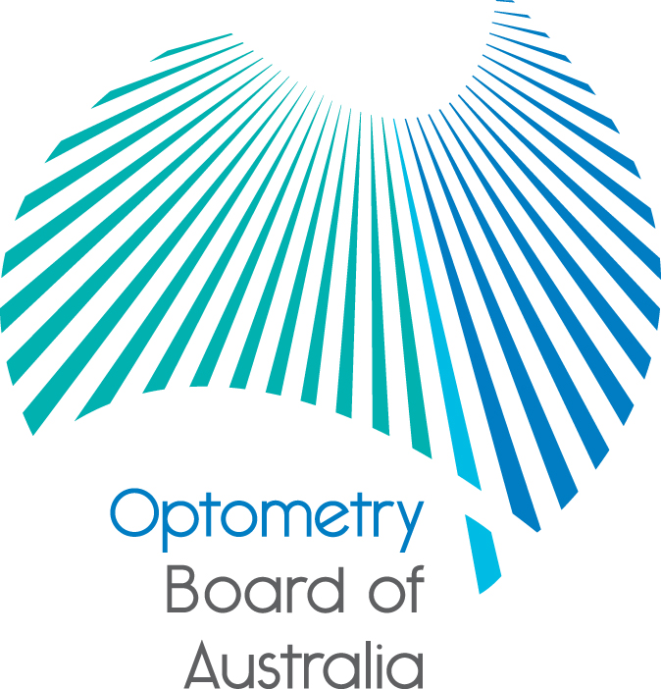
Communiqué: Optometry Board of Australia

May 2019 and June 2019 meetings
The 102nd and 103rd meetings of the Optometry Board of Australia (the Board) were held on 30 May 2019 and 27 June 2019 in Melbourne.
This communiqué outlines the issues and decisions from these meetings as well as other points of interest. We publish it on our website and email it to a broad range of stakeholders. Please forward it to your colleagues and employees who may be interested.
Revised CPD registration standards and guidelines – survey and focus group participants invited
The COAG Health Council comprising Commonwealth, state and territory Ministers of Health has approved the revised continuing professional development (CPD) registration standard.
The Board has agreed to change the CPD assessment from a points system to one based on hours. The revised standards require practitioners to complete 20 hours of CPD annually which meet a set of consistent criteria, and include a minimum of 5 hours CPD in an interactive setting with other practitioners. They draw on the best available evidence about effective CPD, including the requirement for practitioners to document their learning goals, the CPD activities they undertake and their reflection on the effect the CPD has had on their practice.
Registered optometrists with an endorsement in scheduled medicines will be required to complete an additional 10 hours of CPD each year that relates to therapeutic practice.
The Board is seeking feedback from practitioners about what information is required for guidance materials to help practitioners better understand what is required to meet the revised standard.
The Board and the Australian Health Practitioner Regulation Agency (AHPRA) are developing draft guidance materials to support the new standards and provide additional information to assist optometrists to comply with the revised CPD registration standard, which will take effect from 1 December 2020.
The Board would like to test these draft guidance materials with currently registered optometry practitioners and would like to encourage all currently registered optometrists from entry-level to more experienced practitioners working in sole, small or large corporate practices in metropolitan and rural and regional practices to:
- complete a five-minute survey now available on the Board’s home page via this link until 4 August 2019. This survey will help the Board ascertain areas of need and develop guidelines materials to help practitioners meet the revised CPD registration standard; and
- review guidance materials and register to participate in one of two 90-120 minute face-to-face focus group discussions to be conducted by the Board’s members in Melbourne and Sydney, likely to take place mid-October (Melbourne) and mid-November (Sydney) at AHPRA offices. Online Skype facilities to access these focus group discussions will be made available to selected rural, regional and interstate practitioner participants.
Numbers are limited to a maximum of 15 participants for each focus group discussion (a total of 30 participants for both focus groups). Please register by email to participate in one of the two focus groups, with your name, email address and mobile phone number. State your preference for attending the Sydney or Melbourne event by email to EOOptometry.Optometry@ahpra.gov.au. Further details will be made available to selected participants. Please note that the Board will select participants based on its intention to host a cross-section of interested registered practitioners from diverse practice locations.
The Board values the views of registered practitioners and encourages your participation in the survey or focus groups to help shape the draft guidance materials for the revised CPD registration standard for all registered optometrists.
Draft explanatory materials on returning to practice
The Board will shortly be consulting with the professional association and other stakeholders on its draft explanatory materials on returning to practice. The suite of documents includes tips for those taking a break from practice, FAQ and information regarding the Recency of practice registration standard, guidance on completing a professional development plan, a supervised practice plan and a return to practice application checklist. It is anticipated that the explanatory materials will be published later this year.
Review of guidelines for mandatory reporting
Amendments to the Health Practitioner Regulation National Law (National Law) were passed earlier this year in relation to the establishment of new higher thresholds for treating practitioners, employers and education providers to make mandatory notifications about registered health practitioners and students in some situations. The purpose of the requirements is to protect the public. In conjunction with AHPRA, the National Boards have undertaken a risk-based review of the guidelines on mandatory reporting and have made proposed draft revisions to explain the mandatory notification requirements and thresholds. Preliminary consultation on the proposed revised guidelines has begun with National Board stakeholders.
New accreditation funding agreement with the Optometry Council of Australia and New Zealand
A new accreditation funding agreement for a five-year term has been signed by AHPRA on behalf of the Board, with the Optometry Council of Australia and New Zealand. The agreement sets out the accreditation functions to be delivered, associated funding, fee setting and new key performance indicator arrangements within a contemporary framework. The framework addresses accreditation issues such as cultural safety, safety and quality, and reducing regulatory burden and aims to strengthen accountability and transparency of accreditation in the National Registration and Accreditation Scheme.
Multi-Profession Immediate Action Committee appointments
The Board agreed to the appointment of its members, Mr Ian Bluntish and Associate Professor Ann Webber to the Multi-Profession Immediate Action Committee on an alternate basis. As part of a multi-profession model for the management of immediate action matters under the National Law, the Committee has delegated powers to protect the public by taking immediate action as a result of a notification received in respect of a registered practitioner or student. Membership of the Committee comprises practitioner and community members of National Boards.
National Scheme Aboriginal and Torres Strait Islander Health and Cultural Safety Strategy 2020-25
A draft five-year strategy (2020-2025) for the National Scheme has been developed by the Aboriginal and Torres Strait Islander Health Strategy Group. The draft strategy seeks to implement the objectives of the Statement of Intent encompassing a culturally safe health workforce, increased participation in the National Scheme, greater access to culturally safe services of health professions and using leadership and influence to achieve reciprocal goals. It aims to reduce the gap in health outcomes between Aboriginal and Torres Strait Islanders and other Australians. The Board will be considering the strategy in further detail and will participate in initiatives that can help achieve its objectives.
Certificates of registration – pilot project for the discontinuation of hard copy
The Board noted that a pilot project has been conducted by the Nursing and Midwifery Board of Australia. Following a review of the benefits of the pilot project, the Board could implement a similar discontinuation of hard copy certificates of registration in the future.
Fake practitioners face jail and hefty fines
From 1 July 2019, the National Law became tougher on people who pretend to be a registered health practitioner. The penalty for anyone prosecuted by AHPRA under the National Law for these offences now includes bigger fines and the prospect of prison time.
AHPRA has successfully prosecuted multiple cases where people were falsely claiming to be registered practitioners when they were not.
Under the National Law, anyone who calls themselves any of the ‘protected titles’, such as ‘Chinese medicine practitioner, ‘medical practitioner’ or ‘psychologist’, must be registered with the corresponding National Board.
The amendments mean that offenders will be faced with the possibility of a maximum term of three years imprisonment per offence. They also face an increase in the maximum fines from $30,000 to $60,000 per offence for an individual and from $60,000 to $120,000 per offence for a corporate entity.
It is an offence to use one of the protected titles, and it is also an offence to knowingly or recklessly claim to be a registered practitioner when you’re not or use symbols or language that may lead a reasonable person to believe that an individual is a registered health practitioner or is qualified to practise in a health profession. These offences are known as ‘holding out.’
Read the full media release on the AHPRA website.
New video gives a practitioner’s experience of a notification
AHPRA and the Board know that making or being the subject of a notification can be confusing and stressful. We are working to support health consumers and practitioners by improving the way we communicate about notifications.
As part of this work, AHPRA and National Boards released the latest video in our ‘Let’s talk about it’ series. It tells one practitioner’s experience of the process, aiming to help other practitioners who have a notification made about them.
AHPRA has gathered feedback from notifiers and practitioners on their experience of the notifications process. After over 80 interviews and more than 5,000 survey responses, a small number of consistent themes have emerged. These themes are informing the content of our video series.
This latest video, A notification was made about me: A practitioner’s experience, is a powerful first-hand account of a practitioner’s experience engaging with AHPRA and a National Board. It contains a clear message for other health practitioners about seeking support early in the notification process.
Registered health practitioners and their support networks will be encouraged to use this new resource when they are involved in the notifications process.
Chinese medicine practitioners can view the video on the AHPRA website, where practitioners can find additional information on understanding the notifications experience, and on YouTube and Vimeo channels.
Read the full media release on the AHPRA website.
Company fined $30,600 for unlawful advertising
Practitioners are reminded to be truthful in advertising their services after a Sydney company was convicted of 10 charges and fined $30,600 for unlawful advertising.
The Running Clinic (Australia) Pty Ltd (formerly trading as the Heel Clinic), was convicted and fined for advertising offences under the National Law. It was fined $30,600 and ordered to pay AHPRA’s costs of $8,000 in a New South Wales local court in May.
AHPRA filed 10 charges against the company. It alleged that advertising claims on The Running Clinic’s websites and Facebook account contained false, misleading and deceptive claims about podiatry services that were likely to create an unreasonable expectation of beneficial treatment.
AHPRA first raised the unlawful advertising with the company in 2015 and, while minor changes were made, it failed to significantly rectify the issues.
AHPRA CEO Martin Fletcher welcomed the court outcome.
‘Consumers have a right to expect that all registered health practitioners are truthful when advertising their services. This court outcome sends a clear message to anyone advertising a regulated health service that AHPRA will act if they break the law.’ he said
Information about your advertising obligations is available on the AHPRA website.
AHPRA launches WHO Collaborating Centre for Health Workforce Regulation
In April, AHPRA officially launched as a designated World Health Organization (WHO) Collaborating Centre for Health Workforce Regulation in the Western Pacific Region.
AHPRA, working in partnership with the National Boards, joins a list of over 800 institutions in more than 80 countries supporting WHO programs in areas such as nursing development, communicable diseases, mental health, chronic diseases and health technologies.
Strengthening the regulation of the health workforce is an important part of the WHO’s global strategy to build the human resources needed for access to safe and quality healthcare across the world.
As a designated WHO Collaborating Centre for Health Workforce Regulation, AHPRA and National Boards are excited by the opportunity to share expertise and promote dialogue that collectively improves the standard of regulatory practice within the WHO Western Pacific Region. The global health workforce crosses country borders and is mobile, including in Australia where thousands of overseas-qualified practitioners are registered and take up practice here. It’s important that regulators from different countries work together to set the standards for practitioner education, competence and conduct necessary for the global health workforce to deliver safe and reliable healthcare.
As a WHO collaborating centre AHPRA will:
- help the WHO in providing technical support to strengthen health workforce regulatory systems in member states
- support the WHO in promoting the adoption of contemporary regulatory approaches to health workforce regulation, and
- strengthen the capacity, skills and knowledge of regulators in member states under the WHO’s guidance.

Information Publications Scheme – promoting accessibility of our information
From 1 June 2019, AHPRA and National Boards are required to comply with the Information Publication Scheme (IPS) established under the Freedom of Information Act 1982 (Cth). The IPS promotes openness and transparency and aims to reduce the number of Freedom of Information applications through the proactive publication of information. This requires that certain information and documents be made publicly available.
AHPRA and National Boards have worked together to implement the IPS and information has been recently published about it on the AHPRA website.
Are your contact details up to date?
It is important that your contact details are up to date to receive renewal reminders from AHPRA and information from the Board. You can check your details via the Login icon at the top right of the AHPRA website. Email accounts need to be set to receive communications from AHPRA and the Board to avoid misdirection to an account junk box.
Follow AHPRA on social media
Connect with AHPRA on Facebook, Twitter or LinkedIn to receive information about important topics for your profession and participate in the discussion.

Further information
We publish a range of information about registration and our expectations of you as an optometrist on our website at www.optometryboard.gov.au or www.ahpra.gov.au.
For more details or help with questions about your registration, notifications or other matters relevant to the National Scheme, refer to information published on www.ahpra.gov.au or contact AHPRA, send an online enquiry form or call on 1300 419 495.
Ian Bluntish
Chair, Optometry Board of Australia
July 2019

The Optometry Board of Australia is the regulator of optometrists in Australia and acts to protect the public by ensuring that suitably qualified and competent optometrists are registered. The Board is responsible for developing registration standards, codes and guidelines for optometrists and managing notifications (complaints)* about optometrists and optometry students. The Board does this through its powers under the Health Practitioner Regulation National Law, as in force in each state and territory, and the National Registration and Accreditation Scheme, supported by the Australian Health Practitioner Regulation Agency (AHPRA). The Board’s work in regulating Australia’s optometrists in the public interest is underpinned by regulatory principles, which encourage a responsive, risk-based approach to regulation.
*Except in NSW and Qld which have co-regulatory arrangements.

