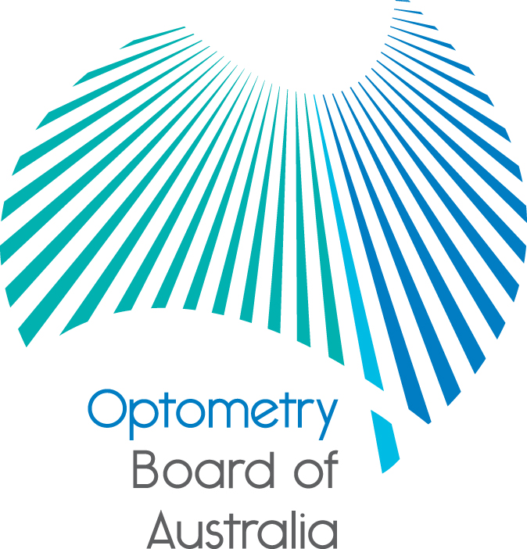
Communiqué: Optometry Board of Australia

May 2017 meeting
The 82nd meeting of the Optometry Board of Australia (the Board) was held on 25 May 2017 at the Australian Health Practitioner Regulation Agency (AHPRA) National office in Melbourne. The Board did not hold a meeting in April.
This communiqué outlines the issues and decisions from this meeting as well as other points of interest. We publish it on our website and email it to a broad range of stakeholders. Please forward it to your colleagues and employees who may be interested.
Update on the review of the Code of Conduct
The Code of Conduct for Optometry is also used by ten other National Boards (Aboriginal and Torres Strait Islander Health Practice, Chinese Medicine, Chiropractic, Dental, Medical Radiation Practice, Occupational Therapy, Osteopathy, Pharmacy, Physiotherapy and Podiatry) with some minor profession-specific changes for some Boards.
The code is a regulatory document that provides an overarching guide to support and inform good practice and to assist practitioners, Boards, employers, health care users and other stakeholders to understand what good practice involves. It seeks to assist and support practitioners to deliver safe and effective health services within an ethical framework.
The Board has started a scheduled review that will draw on best available research and data and involve additional stakeholder consultation and engagement. The Board is working with other National Boards which use the Code on the review.
The review is still at an early research phase. However, the Board is already considering how it can maximise opportunities for input when the consultation stage of the review starts. In addition to public consultation the Board intends to use its website and social media to inform the profession of how it can contribute to the review. The Board will highlight opportunities to be involved in the review in its communiqué and newsletters.
Meeting your legal and professional advertising obligations
Optometrists who advertise health services need to check, correct and comply with their professional and legal advertising obligations.
The National Boards and AHPRA have published a strategy for the National Scheme aimed at keeping health service consumers safe from misleading advertising.
The Advertising compliance and enforcement strategy explains how National Boards and AHPRA will manage advertising complaints and compliance, including the regulatory powers available to deal with breaches of the National Law.
The strategy is designed to keep improving how regulated health services are advertised so healthcare consumers can be better informed.
When preparing advertising, registered health practitioners should always put the consumer first and ensure that their advertising is not false, misleading or deceptive in any way.
This strategy builds on the previous education and enforcement work from National Boards and AHPRA.
More information is available on the Advertising resources section of the AHPRA website and more information will be published in the coming months.
Practitioner audits
The Board discussed practitioner audits for 2017. Audits help to ensure that practitioners are meeting the mandatory registration standards and provide important assurance to the community and the Boards. They are an important part of the way the Board and AHPRA can better protect the public.
More information is found on the Board’s audit webpage.
Prosecution - Anthony Cashman
The Board considers it a serious matter if anyone who is not a registered health practitioner claims to be a registered health practitioner or uses titles that are protected under the National Law (e.g ‘optometrist’). Both are offences and may be prosecuted by AHPRA.

Mr Anthony Patrick Cashman was convicted of six charges and sentenced at the Magistrates Court of Western Australia after he pleaded guilty. The charges, which were brought by AHPRA, relate to holding himself out, and claiming to be a registered optometrist while not being registered, and unlawfully prescribing optical appliances.

Mr Cashman admitted to representing himself as an optometrist and working as an optometrist at an optometry practice in Perth between February 2016 and April 2016. Mr Cashman was previously convicted of similar offences in Western Australia in August 2015. The Court ordered Mr Cashman to pay a fine of $18,000 and costs to AHPRA in the amount of $2,865.

The full news item is on the Board’s website.
Are your contact details up to date?
It is important that your contact details are up to date to receive renewal reminders from AHPRA and information from the Board. You can check your details via the Login icon at the top right of the AHPRA website. Email accounts need to be set to receive communications from AHPRA and the Board to avoid misdirection to an account junk box.
Follow AHPRA on social media
Connect with AHPRA on Facebook,Twitter or LinkedIn to receive information about important topics for your profession and participate in the discussion.

Further information
We publish a range of information about registration and our expectations of you as an optometrist on our website at www.optometryboard.gov.au or www.ahpra.gov.au.
For more details or help with questions about your registration, notifications or other matters relevant to the National Registration and Accreditation Scheme, refer to information published on www.ahpra.gov.au or contact AHPRA, send an online enquiry form or call on 1300 419 495.
Ian Bluntish
Chair, Optometry Board of Australia
June 2017

The Optometry Board of Australia is the regulator of optometrists in Australia and acts to protect the public by ensuring that suitably qualified and competent optometrists are registered. The Board is responsible for developing registration standards, codes and guidelines for optometrists and managing notifications (complaints)* about optometrists and optometry students. The Board does this through its powers under the Health Practitioner Regulation National Law, as in force in each state and territory, and the National Registration and Accreditation Scheme, supported by the Australian Health Practitioner Regulation Agency (AHPRA). The Board’s work in regulating Australia’s optometrists in the public interest is underpinned by regulatory principles, which encourage a responsive, risk-based approach to regulation.
*Except in NSW and Qld which have co-regulatory arrangements.

