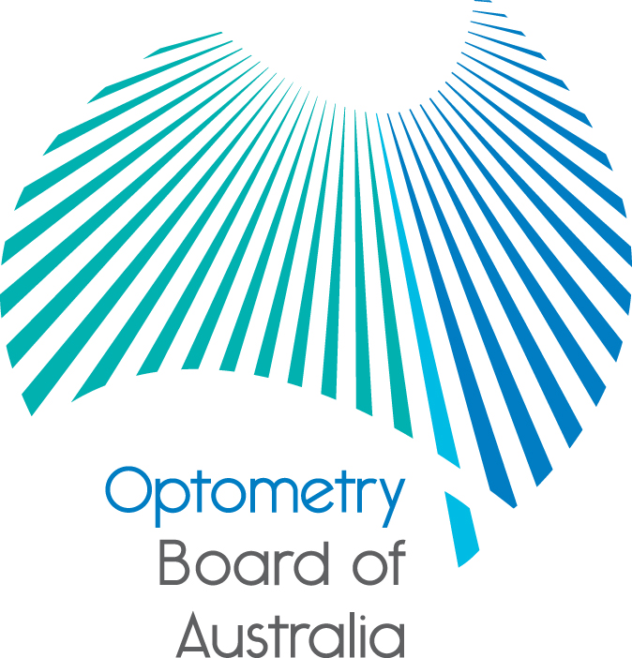
Communiqué: Optometry Board of Australia

May 2018 meeting
The 92nd meeting of the Optometry Board of Australia (the Board) was held on 24 May 2018 at the Australian Health Practitioner Regulation Agency (AHPRA) National office in Melbourne. The Board did not hold a meeting in April.
This communiqué outlines the issues and decisions from this meeting as well as other points of interest. We publish it on our website and email it to a broad range of stakeholders. Please forward it to your colleagues and employees who may be interested.
Practitioner audit will begin soon
Registered optometrists may soon be selected at random for audit. If you are selected for audit, you will receive an audit notice in the mail from AHPRA. It includes a checklist that outlines what supporting documentation is required to demonstrate that you meet the standard(s) being audited.
If you have been selected, please access the Board’s website, which provides comprehensive information about the audit process including guidance on the audit notice and what it means for you, as well as contact details for the audit team and AHPRA customer service team who can assist you with any queries.
Testimonials in health advertising – decision-making tool now available
Advertising about a regulated health service is in breach of the National Law if it includes a testimonial (review, experience, comment and/or statement) that mentions a clinical aspect.
A new tool to help practitioners and advertisers understand their obligations about using testimonials and reviews to advertise regulated health services is now available.
The testimonial tool is the latest in a series of resources and support materials developed by AHPRA and National Boards to help health practitioners, healthcare providers and other advertisers of regulated health services to comply with the National Law.
The tool includes information and flow charts to help practitioners and advertisers understand why testimonials are not allowed and which reviews or feedback can be used in advertising.
The testimonial tool is now available on AHPRA’s website.

Read about progress on the first ever National Scheme Aboriginal and Torres Strait Islander health strategy
The health strategy group charged with developing the National Scheme’s first ever Aboriginal and Torres Strait Islander health strategy has held its first meeting for 2018 and will publish its latest communiqué soon.
AHPRA, the 15 National Boards responsible for regulating the health professions, accreditation authorities and Aboriginal and Torres Strait Islander health sector leaders and organisations have committed to an Aboriginal and Torres Strait Islander health strategy with the vision of: ‘Patient safety for Aboriginal and Torres Strait Islander Peoples in Australia’s health system is the norm, as defined by Aboriginal and Torres Strait Islander Peoples.’
Associate Professor Gregory Phillips, CEO of ABSTARR Consulting, and Dr Joanna Flynn AM, Chair of the Medical Board of Australia, are co-Chairs of the health strategy group. The Aboriginal and Torres Strait Islander health strategy group publishes communiqués of its work. These are available on the Advisory group page of the AHPRA website.
This work is happening in conjunction with the development of a Reconciliation Action Plan for AHPRA.
The next meeting of the Aboriginal and Torres Strait Islander Health Strategy Group is scheduled for July 2018.
Are your contact details up to date?
It is important that your contact details are up to date to receive renewal reminders from AHPRA and information from the Board. You can check your details via the Login icon at the top right of the AHPRA website. Email accounts need to be set to receive communications from AHPRA and the Board to avoid misdirection to an account junk box.
Follow AHPRA on social media
Connect with AHPRA on Facebook, Twitter or LinkedIn to receive information about important topics for your profession and participate in the discussion.
Further information
We publish a range of information about registration and our expectations of you as an optometrist on our website at www.optometryboard.gov.au or www.ahpra.gov.au.
For more details or help with questions about your registration, notifications or other matters relevant to the National Scheme, refer to information published on www.ahpra.gov.au or contact AHPRA, send an online enquiry form or call on 1300 419 495.
Ian Bluntish
Chair, Optometry Board of Australia
May 2018

The Optometry Board of Australia is the regulator of optometrists in Australia and acts to protect the public by ensuring that suitably qualified and competent optometrists are registered. The Board is responsible for developing registration standards, codes and guidelines for optometrists and managing notifications (complaints)* about optometrists and optometry students. The Board does this through its powers under the Health Practitioner Regulation National Law, as in force in each state and territory, and the National Registration and Accreditation Scheme, supported by the Australian Health Practitioner Regulation Agency (AHPRA). The Board’s work in regulating Australia’s optometrists in the public interest is underpinned by regulatory principles, which encourage a responsive, risk-based approach to regulation.
*Except in NSW and Qld which have co-regulatory arrangements.

The Health Practitioner Regulation National Law, as in force in each state and territory.

