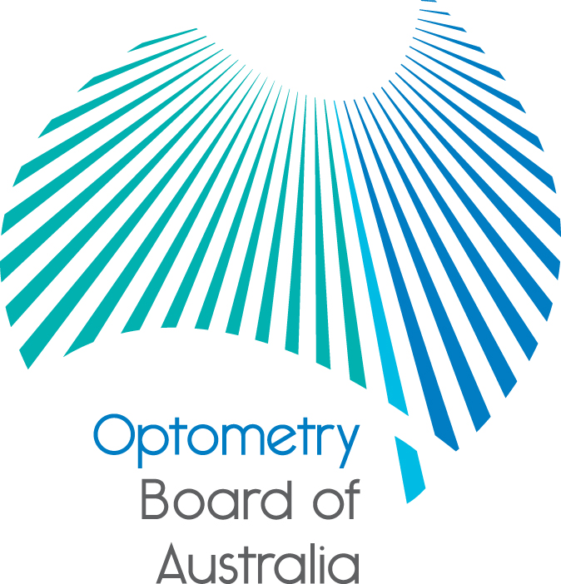
Communiqué

August 2016 meeting of the Optometry Board of Australia
The 76th meeting of the Optometry Board of Australia (the Board) was held on 26 August 2016 in Melbourne.
This communiqué outlines the issues and decisions from this meeting as well as other points of interest. We publish it on our website and email it to a broad range of stakeholders. Please forward it to your colleagues and employees who may be interested.
National Registration and Accreditation Scheme 2016 combined meeting
The National Board meeting was held on 26 August to coincide with the annual National Registration and Accreditation Scheme combined meeting where entities within the scheme got together to discuss the focus for the next 12 months.
The Board invited the Chair and Registrar of the Optometrists and Dispensing Opticians Board of New Zealand to this meeting and discussed issues of mutual interest and common regulatory functions.
National Boards and AHPRA host research summit
The 2016 Research Summit hosted by the 14 National Boards and the Australian Health Practitioner Regulation Agency (AHPRA) was attended by more than 220 delegates who gathered together to talk about the next frontier for developing our partnership’s evidence-base to improve the way we regulate.
The theme of the summit was ‘patient safety through risk-based regulation’, and presenters discussed a range of topics. At the heart of the discussion was how to contribute to safer care for patients and health consumers. Also discussed was how data collection and evaluation can help find new and innovative ways to improve regulatory processes for health practitioners and the public.
The inaugural summit provided an opportunity for the exchange of expertise and ideas between regulatory staff, experts in safety and quality in healthcare, health practitioners and leading health and medical researchers.
Read more in the media release about the summit which was held on 25 August.
Health profession agreement and registration fees
The Board approved the Health Profession Agreement (HPA) 2016–2020 and will shortly publish it on the Board’s website. Under the National Law, the National Boards and AHPRA work in partnership to implement the National Registration and Accreditation Scheme. The HPA provides information about the Board’s financial operations, outlines the partnership between the Board and AHPRA, the services AHPRA will provide to the Board to regulate the profession, and the fees payable by health practitioners.
The Board has approved the registration fees for optometrists for 2016/17. The Board is pleased to reduce the registration fees by $25 to $300. The annual renewal fee will apply from 1 September 2016 and cover the registration period for most practitioners of 1 December 2016 to 30 November 2017. A full fee schedule is published on the Board’s website.
OCANZ Accreditation standards and evidence guide for entry-level optometry programs
The Optometry Council of Australia and New Zealand’s Accreditation Standards and Evidence Guide for Entry-Level Optometry Program, which the Board approved in July, is now available on the Board’s accreditation webpage and will take effect on 1 January 2017.
The Accreditation manual for optometry programs in Australia and New Zealand – Part 2 – Standards April 2006 remain in effect until then.
Responsible advertising
The Board discussed issues around claims in advertising, in particular claims regarding benefits of treatments. The Board would like to remind all practitioners that they must comply with the provisions of the National Law on the advertising of regulated health services, relevant national, state and territory consumer protection legislation and, if applicable, legislation regulating the advertising of therapeutic goods.
All practitioners must be familiar with the Code of Conduct and Guidelines for advertising regulated health services (the guidelines) on the Board’s website. The guidelines equip any person who advertises a regulated health service, or any business that provides a regulated health service, with guidance on the obligations of advertisers under the National Law.
Advertising regulated health services
Section 133 of the National Law regulates the advertising of regulated health services (a service provided by, or usually provided by, a health practitioner as defined in the National Law). Section 133 provides that a person must not advertise regulated health services in a way that:
- is false, misleading or deceptive or is likely to be misleading or deceptive; or
- offers a gift, discount or other inducement to attract a person to use the service or the business, unless the advertisement also states the terms and conditions of the offer; or
- uses testimonials or purported testimonials about the service or business; or
- creates an unreasonable expectation of beneficial treatment; or
- directly or indirectly encourages the indiscriminate or unnecessary use of regulated health services.

Further guidance around claims in advertising is currently being developed and will be made available in the Board’s upcoming newsletter.
Further information
We publish a range of information about registration and our expectations of you as an optometrist on our website at www.optometryboard.gov.au or www.ahpra.gov.au.
For more details or help with questions about your registration, notifications or other matters relevant to the National Registration and Accreditation Scheme, refer to information published on www.ahpra.gov.au or contact AHPRA, send an online enquiry form or call on 1300 419 495.
Ian Bluntish
Chair
Optometry Board of Australia

8 September 2016

The Optometry Board of Australia is the regulator of optometrists in Australia and acts to protect the public by ensuring that suitably qualified and competent optometrists are registered. The Board is responsible for developing registration standards, codes and guidelines for optometrists and managing notifications (complaints)* about optometrists and optometry students. The Board does this through its powers under the Health Practitioner Regulation National Law, as in force in each state and territory, and the National Registration and Accreditation Scheme, supported by the Australian Health Practitioner Regulation Agency (AHPRA). The Board’s work in regulating Australia’s optometrists in the public interest is underpinned by regulatory principles, which encourage a responsive, risk-based approach to regulation.
*Except in NSW and Qld which have co-regulatory arrangements.

