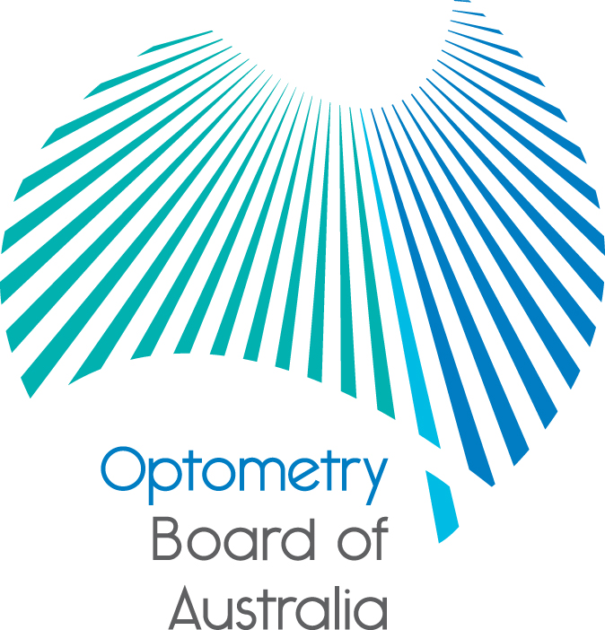
Communiqué: Optometry Board of Australia

June 2018 meeting
The 93rd meeting of the Optometry Board of Australia (the Board) was held on 28 June 2018 at the Australian Health Practitioner Regulation Agency (AHPRA) National office in Melbourne.
This communiqué outlines the issues and decisions from this meeting as well as other points of interest. We publish it on our website and email it to a broad range of stakeholders. Please forward it to your colleagues and employees who may be interested.
Revised registration standard and guidelines for endorsement for scheduled medicines approved by Ministerial Council
The Board has published the revised Endorsement for scheduled medicines registration standard (registration standard) and the Guidelines for use of scheduled medicines (guidelines) on 18 June 2018. The COAG Health Council (Ministerial Council) approved the revised registration standard and guidelines on 31 May 2018, with an effective date of 10 September 2018.
The Board encourages registered optometrists to familiarise themselves with this guidance to ensure their practice meets the Board’s expectations.
The registration standard and guidelines have been updated as a result of a scheduled review, following wide-ranging public consultation in 2017.
The Board-approved list of topical schedule medicines that endorsed optometrists are qualified to prescribe for the purposes of the practice of optometry is also published on the Board’s website and takes effect on 10 September 2018. The current registration standard, guidelines and list remain in effect until then.
An FAQ has been developed to provide further information regarding the changes and the Board’s expectations.
The revised registration standard, guidelines and new FAQ is available on the Board’s Registration Standards page.
Scheduled Medicines Advisory Committee appointments
The Board considered applications from registered optometrists and medical practitioners seeking appointment to the Scheduled Medicines Advisory Committee (the Committee) in early 2018.
The Board has now appointed new members to the Committee. The Board would like to welcome Associate Professor Andrew Symons, Mr Benjamin Hamlyn and welcome back Professor Alex Gentle to the Committee.
In acknowledgement of their service, the Board would like to thank Professor Fiona Stapleton and Dr Diane Webster for their significant contribution to the Committee over the years.
The primary role of the Board is to protect the public. The role of the Committee is to advise the Board on matters with respect to the administration or prescribing of scheduled medicines by optometrists for diagnostic or therapeutic purposes.
The updated Committee membership and terms of reference may be found on the Board’s website.
To receive notice of future advertised Committee or Board vacancies, please contact Statutory Appointments.
Selectively editing reviews or testimonials may break the law
AHPRA has published further guidance for advertisers of regulated health services to emphasise that selectively editing reviews or testimonials has the potential to break the law.
The recent example of an organisation only publishing positive reviews and removing all negative information from consumer reviews shows the importance of advertisers understanding their advertising obligations under all relevant legislation.
Selectively editing reviews or testimonials has the potential to be false, misleading or deceptive and, therefore, be unlawful.
More information is available on the Board’s news webpage.
Are your contact details up to date?
It is important that your contact details are up to date to receive renewal reminders from AHPRA and information from the Board. You can check your details via the Login icon at the top right of the AHPRA website. Email accounts need to be set to receive communications from AHPRA and the Board to avoid misdirection to an account junk box.
Follow AHPRA on social media
Connect with AHPRA on Facebook, Twitter or LinkedIn to receive information about important topics for your profession and participate in the discussion.
Further information
We publish a range of information about registration and our expectations of you as an optometrist on our website at www.optometryboard.gov.au or www.ahpra.gov.au.
For more details or help with questions about your registration, notifications or other matters relevant to the National Scheme, refer to information published on www.ahpra.gov.au or contact AHPRA, send an online enquiry form or call on 1300 419 495.
Ian Bluntish
Chair, Optometry Board of Australia
June 2018

The Optometry Board of Australia is the regulator of optometrists in Australia and acts to protect the public by ensuring that suitably qualified and competent optometrists are registered. The Board is responsible for developing registration standards, codes and guidelines for optometrists and managing notifications (complaints)* about optometrists and optometry students. The Board does this through its powers under the Health Practitioner Regulation National Law, as in force in each state and territory, and the National Registration and Accreditation Scheme, supported by the Australian Health Practitioner Regulation Agency (AHPRA). The Board’s work in regulating Australia’s optometrists in the public interest is underpinned by regulatory principles, which encourage a responsive, risk-based approach to regulation.
*Except in NSW and Qld which have co-regulatory arrangements.

