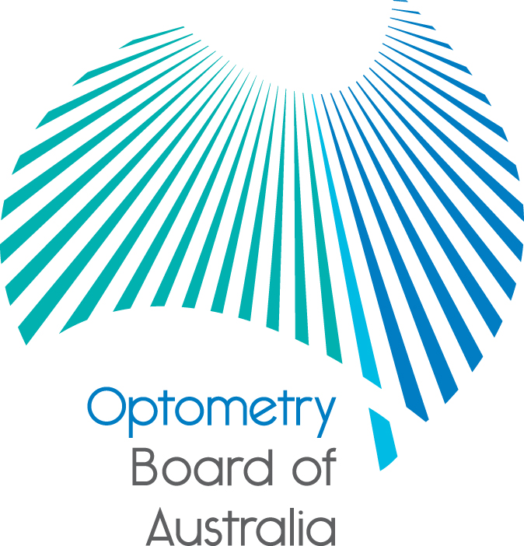
Communiqué: Optometry Board of Australia

November 2016 meeting
The 78th meeting of the Optometry Board of Australia (the Board) was held on 24 November 2016 at the Australian Health Practitioner Regulation Agency (AHPRA) National office in Melbourne.
This communiqué outlines the issues and decisions from this meeting as well as other points of interest. We publish it on our website and email it to a broad range of stakeholders. Please forward it to your colleagues and employees who may be interested.
Reminder: renewal of registration for 2016/17, late fees and lapsed registrations
Registration renewal for optometrists is due on 30 November 2016. Under the National Law, optometrists are responsible for renewing their registration on time each year.
Applications for general and non-practising registration renewals received within a month after the expiry date will incur a late fee. Optometrists who do not renew registration within one month of their registration expiry date will have their name removed from the national register of practitioners. Their registration will lapse and they will not be able to practise or work as an optometrist in Australia until a new application for registration is approved.
2015/16 National Scheme annual report
AHPRA and the National Boards have released their 2015/16 annual report on the National Registration and Accreditation Scheme (the National Scheme), providing a comprehensive record of the operations of the National Scheme for the 12 months ending 30 June 2016.
The Board continued its regular reviews of registration standards and guidelines to ensure they remain
up-to-date and relevant to the profession. A new Recency of practice registration standard took effect on 1 December 2015, Guidelines on the prescription of optical appliances took effect on 1 June 2016, and the Professional indemnity insurance arrangements registration standard took effect on 1 July 2016.
The Board continues to consult with the profession and other stakeholders on the endorsement of scheduled medicines and continuing professional development standards and guidelines.
For detailed data and information relating to the Board in 2015/16, please see the 2015/16 annual report. The report provides a nationwide snapshot of the work of AHPRA and the Boards and highlights a multi profession approach to risk-based regulation with a clear focus on ensuring that Australians have a safe and competent health workforce.
Supplementary tables that break down data across categories such as registrations, notifications, statutory offences, tribunals and appeals, and monitoring and compliance can also be found on the annual report website.
In the coming months, AHPRA and the National Boards will also publish summaries of our work regulating health practitioners in every state and territory, which will be released in late 2016. Expanded, profession-specific summaries will also be released and progressively published from early 2017.
Health profession agreement
The Board and AHPRA have published the health profession agreement (HPA) for 2016–20.
Under the National Law, the Board and AHPRA work in partnership to implement the National Registration and Accreditation Scheme (National Scheme), each with specific roles, powers and responsibilities set down in the National Law.
The HPA sets out the partnership between the Board and AHPRA, and the services AHPRA will provide in supporting the Board to carry out its functions.
The Board and AHPRA work together to implement the National Scheme, which regulates registered health practitioners in Australia, in the public interest.
The 2016-20 Optometry Board of Australia and AHPRA Health Profession Agreement is available on the Health Profession Agreements page.
For more information, refer to the Board’s news item.
Are your contact details up-to-date?
It is important that your contact details are up to date to receive renewal reminders from AHPRA and information from the Board. You can check your details via the Login icon at the top right of the AHPRA website. Email accounts need to be set to receive communications from AHPRA and the Board to avoid misdirection to an account junk box.
Further information
We publish a range of information about registration and our expectations of you as an optometrist on our website at www.optometryboard.gov.au or www.ahpra.gov.au.
For more details or help with questions about your registration, notifications or other matters relevant to the National Registration and Accreditation Scheme, refer to information published on www.ahpra.gov.au or contact AHPRA, send an online enquiry form or call on 1300 419 495.
Ian Bluntish
Chair
Optometry Board of Australia

30 November 2016

The Optometry Board of Australia is the regulator of optometrists in Australia and acts to protect the public by ensuring that suitably qualified and competent optometrists are registered. The Board is responsible for developing registration standards, codes and guidelines for optometrists and managing notifications (complaints)* about optometrists and optometry students. The Board does this through its powers under the Health Practitioner Regulation National Law, as in force in each state and territory, and the National Registration and Accreditation Scheme, supported by the Australian Health Practitioner Regulation Agency (AHPRA). The Board’s work in regulating Australia’s optometrists in the public interest is underpinned by regulatory principles, which encourage a responsive, risk-based approach to regulation.
*Except in NSW and Qld which have co-regulatory arrangements.

