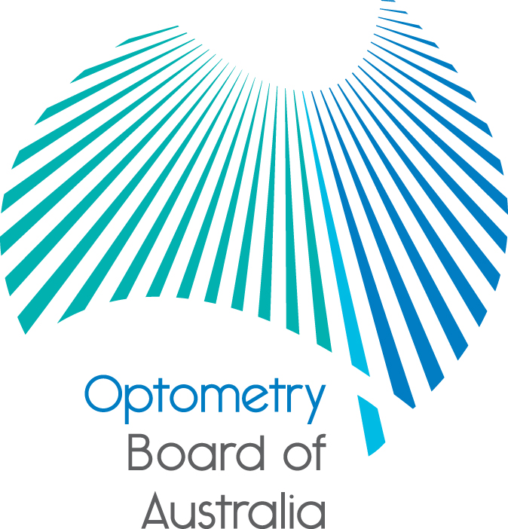
Communiqué
The 75th meeting of the Optometry Board of Australia (the Board) was held on 23 June 2016 at the Australian Health Practitioner Regulation Agency (AHPRA) national office in Melbourne.
This communiqué outlines the issues and decisions from this meeting as well as other points of interest. We publish it on our website and email it to a broad range of stakeholders. Please forward it to your colleagues and employees who may be interested.
Revised Registration and Notification Committee (RNC) terms of reference
The Board has revised the RNC terms of reference to provide greater flexibility for community member participation in the unlikely event a community member of the Board is unavailable. The revised terms of reference are available on the Board’s website.
Revised standard: Professional Indemnity Insurance arrangements take effect on 1 July 2016
In December 2015, the Board published a revised registration standard for professional indemnity insurance (PII) arrangements that takes effect on 1 July 2016. The revised standard applies to all registered optometrists except those with non-practising registration.
More information is found on the Board’s website.
Nomination for member to OCANZ
Expressions of interest were sought from optometrists for nomination for a member of the Optometry Council of Australia and New Zealand (OCANZ). The Board is pleased to nominate Colin Waldron as the Board’s nominee for three years and look forward to reports on the activities he undertakes in this role.
Whenever expressions of interest are called for by the Board, the information is available on the Committee member recruitment page on AHPRA’s website.
National awareness campaign
The third and final phase of AHPRA’s national awareness campaign is underway.
Under the headline of Safe in the knowledge, the phase targets the public to increase awareness of the national register of health practitioners and encourages them to check it before visiting their practitioner.
The AHPRA website has been updated with additional information on what the public can do if a practitioner can’t be found on the register.
As part of the campaign, employers of health practitioners have been urged to understand their obligations while practitioners have also been encouraged to stay up to date with regulation changes as they occur, and to be aware of their obligations as registered practitioners.
Further information
We publish a range of information about registration and our expectations of you as an optometrist on our website at www.optometryboard.gov.au or www.ahpra.gov.au.

For more details or help with questions about your registration, notifications or other matters relevant to the National Registration and Accreditation Scheme, refer to information published on www.ahpra.gov.au or contact AHPRA, send an online enquiry form or call on 1300 419 495.
Ian Bluntish
Chair
Optometry Board of Australia
5 July 2016

The Optometry Board of Australia is the regulator of optometrists in Australia and acts to protect the public by ensuring that suitably qualified and competent optometrists are registered. The Board is responsible for developing registration standards, codes and guidelines for optometrists and managing notifications (complaints)* about optometrists and optometry students. The Board does this through its powers under the Health Practitioner Regulation National Law, as in force in each state and territory, and the National Registration and Accreditation Scheme, supported by the Australian Health Practitioner Regulation Agency (AHPRA). The Board’s work in regulating Australia’s optometrists in the public interest is underpinned by regulatory principles, which encourage a responsive, risk-based approach to regulation.
*Except in NSW and QLD which have co-regulatory arrangements.

