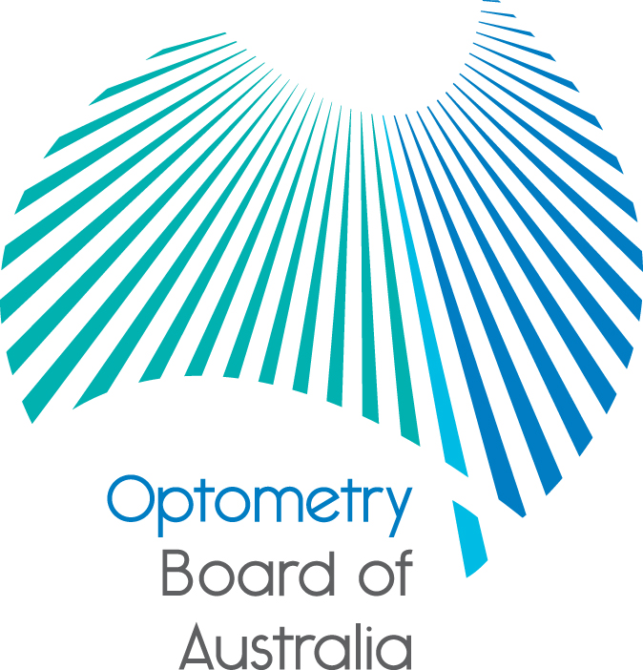
Communiqué
The 73rd meeting of the Optometry Board of Australia (the Board) was held on 28 April 2016 at the Australian Health Practitioner Regulation Agency (AHPRA) national office in Melbourne.
This communiqué outlines the issues and decisions from this meeting as well as other points of interest. We publish it on our website and email it to a broad range of stakeholders. Please forward it to your colleagues and employees who may be interested.
2016 Revised guidelines on the prescription of optical appliances published
The Board approved a revised guideline on the prescription of optical appliances in March 2016 prior to taking effect on 1 June 2016. The revision of the guideline was in response to a scheduled review. The Board has not experienced any major issues in relation to compliance with the guidelines and has not made any significant changes as a result of the consultation. The guidelines have been published on the Board’s website to enable registrants to become familiar with the guidelines before they come into effect on 1 June 2016.
Reminder expression of interest closing – nominee for member of the Optometry Council of Australia and New Zealand (OCANZ)
The Board is inviting applications from suitably qualified and experienced optometrists interested in being the Board’s nominee for member of the Optometry Council of Australia and New Zealand (OCANZ). The Board would like to take this opportunity to thank Geoff Leunig for his work as the Board’s previous nominee.
The role of the members is to appoint the OCANZ Board of Directors and receive the annual report and financial statements, as well as having significant legal responsibilities as the joint ‘owners’ of OCANZ including oversight of the constitution. The nominated person for director of OCANZ will be asked to represent the interests of the Board with the understanding they are not an agent of the Board.
The Board will require a brief annual written report summarising the activities as a member of OCANZ. Further information is available on the Boards website and applications close Monday 30 May 2016.
Responsible advertising
The Board would like to remind all registered optometrists that you must comply with the provisions of the National Law on the advertising of regulated health services, relevant consumer protection legislation, and state and territory fair trading Acts and, if applicable, legislation regulating the advertising of therapeutic goods. Good practice also involves ensuring that any promotion of therapeutic products is ethical.
All practitioners must be familiar with the Code of Conduct and Guidelines for advertising regulated health services (the guidelines). The guidelines provide any person who advertises a regulated health service or business that provides a regulated health service with guidance on the obligations of advertisers under the National Law.
The National Law bans specific types of advertising, including (but not limited to) advertising in a way that:
  - makes misleading claims
  - offers an inducement such as a gift or discount (unless the relevant terms and conditions are also included)
  - uses testimonials, and/or
  - creates unreasonable expectations of beneficial treatment, or encourages the indiscriminate or unnecessary use of a service.
The Board would encourage you to check your website against the banned types of advertising to avoid any inadvertent breaches of the National Law.
Myopia control
It has been bought to the attention of the Board there is currently an issue being experienced by some optometrists about the management of myopia control. The Board have referred these issues to the professional association, Optometry Australia, to work towards a solution to resolve the issue. If you have a concern or questions regarding myopia control, please contact Optometry Australia on (03) 9668 8500.
Quarterly registration data released
The Board has released its quarterly registration data as at December 2015. The latest report and other statistics are published on our website under Statistics.
Optometry regulation at work in Australia, 2014/15
The Board has released its report for 2014/15.
During 2014/15 the Board revised its guidelines for the use of scheduled medicines which were published in December 2014 (these were a revised version of guidelines published in 2013). These guidelines enable optometrists to diagnose, initiate, treat and monitor chronic glaucoma patients. The revised guidelines enhance the early diagnosis and treatment of chronic glaucoma in the best interest of the public, and clarify the timelines for information exchange between treating optometrists and ophthalmologists.
The Board’s registration standard for general registration for initial applicants came into effect on 1 December 2014, which acknowledges that the current undergraduates from Board approved programs leading to general registration incorporates ocular therapeutics as part of their undergraduate degree and enables those graduates to be automatically eligible for the scheduled medicines endorsement upon application for registration.
Highlights

- 4,915 registered optometrists in Australia on 30 June 2015.
- 33% of optometrists are aged under 35.
- 55 notifications received relates to about 1.1% of registered optometrists.
- 63% of the notifications received were closed following assessment (excluding New South Wales).
- 16 registered optometrists under active monitoring, 56% due to suitability/eligibility.
A copy of the report can be downloaded from the Board’s website.
Quarterly performance reports released
AHPRA and the National Boards, including the Board, have released new information about their performance in each state and territory to improve transparency and accountability.
The comprehensive information and data has been published on the AHPRA website to help the community and health practitioners better understand what AHPRA and the National Boards do and how.
The quarterly performance reports include data specific to each state and territory for the period October to December 2015 and covers AHPRA and the National Boards’ main areas of activity in implementing the National Scheme.
To provide feedback on the reports email: reportingfeedback@ahpra.gov.au.
Further information
We publish a range of information about registration and our expectations of you as an optometrist on our website at www.optometryboard.gov.au or www.ahpra.gov.au.
Ian Bluntish
Chair
Optometry Board of Australia
25 May 2016

