

Optometry Board of Australia

Registrant data

Reporting period: 1 October 2018 – 31 December 2018

Table of contents
Introduction 3
Principal place of practice 4
1. Registration type 4
2. Endorsements 5
Age group 6
3. Registration type 6
Gender 9
4. Percentage 9

Introduction
The role of the Optometry Board of Australia (the Board) include:
- registering optometrists and students
- developing standards, codes and guidelines for the optometry profession
- handling notifications, complaints, investigations and disciplinary hearings
- overseeing the assessment of overseas trained practitioners who wish to practise in Australia, and
- approving accreditation standards and accredited courses of study.
The Board’s functions are supported by the Australian Health Practitioner Regulation Agency (AHPRA). For information about legislation governing our operations see About AHPRA at www.ahpra.gov.au/About-AHPRA/What-We-Do/Legislation.aspx.
The Board has analysed its registration data and produced a number of statistical breakdowns about registrants to share with the profession and community. The Board shares these breakdowns regularly.
For more information on optometry registration, please see the Board’s website: www.optometryboard.gov.au/Registration.aspx

Principal place of practice
- Registration type
  - Registration type by principal place of practice
Registration Type | Registration Sub-type | ACT | NSW | NT | QLD | SA | TAS | VIC | WA | No PPP | Total
General |  | 84 | 1,825 | 33 | 1,109 | 325 | 106 | 1,479 | 429 | 102 | 5,492
Limited | Postgraduate training or supervised practice | 1 | 3 |  | 2 | 1 |  | 1 | 3 | 1 | 12
Limited | Teaching or research |  | 1 |  |  | 1 |  |  |  |  | 2
Non-practising |  | 2 | 44 |  | 17 | 1 | 1 | 34 | 4 | 66 | 169
Total |  | 87 | 1,873 | 33 | 1,128 | 328 | 107 | 1,514 | 436 | 169 | 5,675

  - Principal place of practice percentages

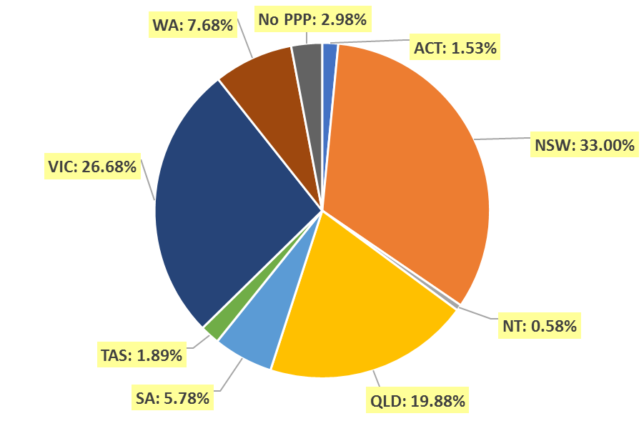

- Endorsements
  - Endorsements
Endorsement | ACT | NSW | NT | QLD | SA | TAS | VIC | WA | No PPP | Total
Scheduled Medicines* | 47 | 853 | 25 | 635 | 224 | 80 | 1,104 | 230 | 34 | 3,232
% of general registrants who are endorsed | 56.0% | 46.7% | 75.8% | 57.3% | 68.9% | 75.5% | 74.6% | 53.6% | 33.3% | 58.8%

  - Endorsements by age group
Age Group | Scheduled Medicines* | % of General Registrants
U - 25 | 295 | 99.7%
25 - 29 | 963 | 97.2%
30 - 34 | 583 | 81.2%
35 - 39 | 390 | 57.9%
40 - 44 | 286 | 48.9%
45 - 49 | 235 | 39.8%
50 - 54 | 178 | 34.2%
55 - 59 | 164 | 33.3%
60 - 64 | 93 | 22.9%
65 - 69 | 38 | 25.2%
70 - 74 | 6 | 14.6%
75 - 79 | 1 | 4.3%
80+ |  | 0.0%
Total | 3,232 | 58.8%

*Only Optometrists holding general registration are eligible to hold the scheduled medicines endorsement.

Age group
- Registration type
  - Registrants by age group
Age Group | General |  | Limited |  |  |  | Non-practising |  | Total
Age Group |  |  | Postgraduate training or supervised practice |  | Teaching or research
Age Group | Female | Male | Female | Male | Female | Male | Female | Male | Female | Male | Total
U - 25 | 228 | 68 |  |  |  |  |  |  | 228 | 68 | 296
25 - 29 | 661 | 330 | 3 | 1 |  |  | 4 |  | 668 | 331 | 999
30 - 34 | 477 | 241 | 2 | 1 | 1 | 1 | 18 | 1 | 498 | 244 | 742
35 - 39 | 440 | 233 | 1 | 3 |  |  | 13 | 4 | 454 | 240 | 694
40 - 44 | 331 | 254 | 1 |  |  |  | 12 | 9 | 344 | 263 | 607
45 - 49 | 318 | 273 |  |  |  |  | 13 | 10 | 331 | 283 | 614
50 - 54 | 229 | 292 |  |  |  |  | 14 | 12 | 243 | 304 | 547
55 - 59 | 173 | 319 |  |  |  |  | 6 | 15 | 179 | 334 | 513
60 - 64 | 89 | 317 |  |  |  |  | 7 | 13 | 96 | 330 | 426
65 - 69 | 43 | 108 |  |  |  |  | 3 | 6 | 46 | 114 | 160
70 - 74 | 1 | 40 |  |  |  |  | 1 | 5 | 2 | 45 | 47
75 - 79 | 2 | 21 |  |  |  |  |  | 3 | 2 | 24 | 26
80+ |  | 4 |  |  |  |  |  |  |  | 4 | 4
Total | 2,992 | 2,500 | 7 | 5 | 1 | 1 | 91 | 78 | 3,091 | 2,584 | 5,675

Registrants age group, by principal place of practice and gender – General and Limited
Age Group | ACT |  | NSW |  | NT |  | QLD |  | SA |  | TAS |  | VIC |  | WA |  | No PPP |  | Total
 | F | M | F | M | F | M | F | M | F | M | F | M | F | M | F | M | F | M | Total
U - 25 | 4 |  | 69 | 17 | 3 | 1 | 57 | 19 | 18 | 9 | 8 | 2 | 57 | 14 | 12 | 6 |  |  | 296
25 - 29 | 11 | 6 | 198 | 111 | 4 | 2 | 121 | 58 | 63 | 17 | 8 | 3 | 219 | 104 | 36 | 25 | 4 | 5 | 995
30 - 34 | 4 | 6 | 149 | 73 | 3 |  | 92 | 48 | 23 | 16 | 4 | 4 | 170 | 82 | 31 | 12 | 4 | 2 | 723
35 - 39 | 9 | 3 | 171 | 70 | 2 | 1 | 80 | 53 | 26 | 10 | 4 | 2 | 103 | 70 | 38 | 21 | 8 | 6 | 677
40 - 44 | 9 | 5 | 117 | 60 | 1 | 2 | 65 | 64 | 15 | 17 | 6 | 5 | 82 | 77 | 31 | 21 | 6 | 3 | 586
45 - 49 | 8 | 7 | 113 | 75 | 2 | 2 | 68 | 66 | 11 | 20 | 5 | 9 | 78 | 56 | 27 | 33 | 6 | 5 | 591
50 - 54 | 1 | 3 | 83 | 86 |  | 1 | 52 | 65 | 5 | 12 | 4 | 7 | 60 | 75 | 15 | 37 | 9 | 6 | 521
55 - 59 | 1 | 4 | 69 | 104 | 2 | 5 | 36 | 68 | 5 | 20 | 7 | 10 | 38 | 69 | 7 | 29 | 8 | 10 | 492
60 - 64 | 1 | 3 | 50 | 139 |  | 1 | 9 | 50 | 6 | 23 | 1 | 10 | 14 | 61 | 6 | 22 | 2 | 8 | 406
65 - 69 |  |  | 20 | 38 | 1 |  | 6 | 21 | 2 | 6 |  | 5 | 12 | 22 |  | 11 | 2 | 5 | 151
70 - 74 |  |  |  | 7 |  |  |  | 10 |  | 1 |  | 1 | 1 | 10 |  | 7 |  | 4 | 41
75 - 79 |  |  | 1 | 7 |  |  |  | 3 |  | 2 |  | 1 | 1 | 5 |  | 3 |  |  | 23
80+ |  |  |  | 2 |  |  |  |  |  |  |  |  |  |  |  | 2 |  |  | 4
Total | 48 | 37 | 1,040 | 789 | 18 | 15 | 586 | 525 | 174 | 153 | 47 | 59 | 835 | 645 | 203 | 229 | 49 | 54 | 5,506

  - Registrants age group, by principal place of practice and gender – Non-practising
Age Group | ACT |  | NSW |  | NT |  | QLD |  | SA |  | TAS |  | VIC |  | WA |  | No PPP |  | Total
 | F | M | F | M | F | M | F | M | F | M | F | M | F | M | F | M | F | M | Total
U - 25 |  |  |  |  |  |  |  |  |  |  |  |  |  |  |  |  |  |  | 0
25 - 29 |  |  |  |  |  |  |  |  |  |  |  |  | 2 |  |  |  | 2 |  | 4
30 - 34 |  |  | 3 | 1 |  |  | 2 |  |  |  |  |  | 5 |  |  |  | 8 |  | 19
35 - 39 |  |  | 5 |  |  |  |  | 2 |  |  |  |  | 3 | 1 | 1 |  | 4 | 1 | 17
40 - 44 |  |  | 1 | 4 |  |  | 1 |  |  |  |  |  | 5 | 3 |  |  | 5 | 2 | 21
45 - 49 |  |  | 4 | 2 |  |  |  |  |  |  |  |  | 2 | 2 |  |  | 7 | 6 | 23
50 - 54 |  |  | 5 | 2 |  |  | 3 |  | 1 |  |  |  | 1 | 4 | 1 |  | 3 | 6 | 26
55 - 59 |  | 1 | 1 | 4 |  |  |  |  |  |  |  |  |  |  |  | 1 | 5 | 9 | 21
60 - 64 |  | 1 |  | 5 |  |  | 2 | 3 |  |  |  | 1 | 1 |  | 1 |  | 3 | 3 | 20
65 - 69 |  |  | 1 | 3 |  |  | 1 | 1 |  |  |  |  | 1 | 1 |  |  |  | 1 | 9
70 - 74 |  |  |  | 1 |  |  |  | 2 |  |  |  |  | 1 | 2 |  |  |  |  | 6
75 - 79 |  |  |  | 2 |  |  |  |  |  |  |  |  |  |  |  |  |  | 1 | 3
80+ |  |  |  |  |  |  |  |  |  |  |  |  |  |  |  |  |  |  | 0
Total |  | 2 | 20 | 24 |  |  | 9 | 8 | 1 |  |  | 1 | 21 | 13 | 3 | 1 | 37 | 29 | 169

  - Registrants by age group

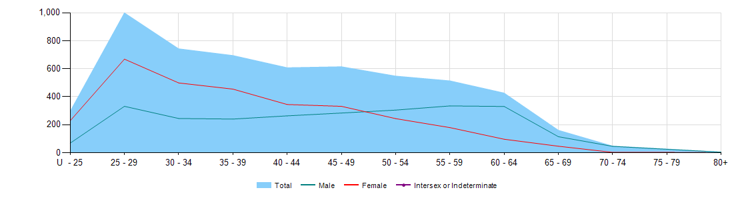

Gender
- Percentage
  - Registrants by gender percentages
Gender | ACT | NSW | NT | QLD | SA | TAS | VIC | WA | No PPP | Total
Female | 55.2% | 56.6% | 54.5% | 52.7% | 53.4% | 43.9% | 56.5% | 47.2% | 50.9% | 54.5%
Male | 44.8% | 43.4% | 45.5% | 47.3% | 46.6% | 56.1% | 43.5% | 52.8% | 49.1% | 45.5%

